Plans for a phased re-opening of Church Lane Primary School and Nursery

I would like to thank you for your patience over the last week or two whilst I prepared a risk assessment for return to school. I understand that you as parents have had a tough job keeping children entertained often within the confines of your own homes 24 hours a day 7 days a week for the last 10 weeks. From the many parents I have spoken to, it sounds like you have been doing a fantastic job.

Over the last 10 weeks, school have been providing care to key worker and vulnerable children every day, have made over 1250 calls to families to check in with them, have delivered new packs of work out to families daily, have delivered just over 900 food boxes/ pack lunches to families, have been communicating daily with families via Twitter, Facebook and email, have had our schools play therapist Karen supporting children over the phone and have worked closely with the foodbanks and Tesco to provide fresh fruit and vegetables to families. I hope, despite this being a difficult time, that you have all felt supported in some way by us and on behalf of the staff would like to thank you for the messages you had in windows, letters you sent us, great messages on email/Facebook etc. They really have kept us going.

We now begin to move to the next phase, where we are moving from our holiday club type approach (which has run over the last 10 weeks) back into formal learning. We aim to make this transition as smooth as possible however it does mean some change for those already attending. From 1st June 2020, the key worker/vulnerable children already attending school and those who will start to attend will begin formal learning once again within school.
Our plan has safety at the heart of it – safety for the whole school community
Our children are at the centre of all that we do and we desperately want to have our children back in school; however, safety and safeguarding are always our number one priorities.
Whilst there are no guarantees that we will not have cases of COVID-19 in school, we can, and have, put in preventative measures to protect our children, staff and families.

The decision has been made to introduce individual year groups slowly back into school to allow children, families and staff time to get to grips with the changes. We will begin to open more of the school up over the space of the week. We will only open further areas of school up, so long as our own internal conditions are met, these are:
- Sufficient staffing
- Safety measures
- Capacity to keep the site clean
Our phased re-opening plan subject to the government’s 5 tests and schools internal tests being met:
- Monday 1st June 2020- School will be open for Nursery and Keyworker and vulnerable pupils (those who have been attending school for the last 10 weeks) and we will prioritise these pupils first. As of Monday 1st June 2020, these pupils will need to begin attending school through their new classroom doors.

- Tuesday 2nd and Wednesday 3rd June 2020- School will be open to the above plus our Reception children.

- Thursday 4th and Friday 5th June 2020- School will be open for the above groups plus Year 1

- Monday 8th June 2020- School will plan to reopen for pupils in Year 6 if it is feasible. (Whilst we anticipate having sufficient space for Year 6, we need to ensure that we prioritise the children of keyworkers, Nursery, Reception and Year 1 as per government guidance. This is ensuring we have sufficient staffing, cleaning and we are able to manage risk)
- School will continue to be closed for years 2, 3, 4 and 5

We will be welcoming children back to school in groups of 8 for Nursery and groups of 8 for Reception, groups of 15 for Year 1 and groups of 15 for Year 6.
This allows all children in those year groups the opportunity to get used to being back in school and to learn how to stay safe in school.

Social Distancing
‘We know that, unlike older children and adults, early years and primary age children cannot be expected to remain 2 metres apart from each other and staff. In deciding to bring more children back to early years and schools, we are taking this into account. Schools should therefore work through a hierarchy of measures set out above:
  - Avoiding contact with anyone with symptoms
  - Frequent hand cleaning and good respiratory hygiene practices
  - Regular cleaning of settings
  - Minimising contact and mixing
It is still important to reduce contact between people as much as possible, and we can achieve that and reduce transmission risk by ensuring children, young people and staff, where possible, only mix in a small, consistent group and that small group stays away from other people and groups.
Public Health England is clear that if early years settings, schools and colleges do this, and crucially if they are also applying regular hand cleaning, hygiene and cleaning measures and handling potential cases of the virus as per the advice, then the risk of transmission will be lowered. Where settings can keep children and young people in those small groups 2 metres away from each other, they should do so. (Coronavirus (COVID-19): implementing protective measures in education settings, DFE, May 2020)

School Hours
School hours for all pupils will be similar to normal school hours but there will be staggered start and finish times, to maximise social distancing at these times and minimise the number of people on our school site at any one time.

  - Children of keyworkers will start at 8.30am and finish at 3.00pm
  - Nursery sessions will work 9-12 and 12-3 (key workers can be dropped off at 8:30)
  - Reception will start at 8:30 and finish 2:30 (key workers can be dropped off at 8:30 and remain till 3pm)
  - Year 1 children will start at 8:45am and finish at 14:45 pm (key workers can be dropped off at 8:30 and remain till 3pm)
  - Year 6 children will start at 9am and finish at 3.00pm (key workers can be dropped off at 8:30)
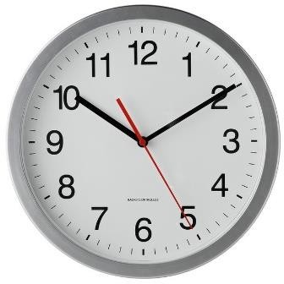

  - Families with more than one child in Nursery, Reception, Year 1 and Year 6 will need to work to the earliest start times for all their children. In the instance that parents have children in more than one year group, parents may collect children from their classroom doors.
  - For all keyworker families the start time for all children will be 8.30am and end time will be 3.00pm.
  - We cannot accommodate early arrivals or late starts. Children must arrive at school within the allocated 15 minutes unless the pupil has siblings attending school.
  - Children must be collected at the agreed time.
  - School places have been allocated for five days a week. Unfortunately there can be no ‘dipping in or out’ of a school place. If the decision has been for your child to return to school, they must be in school for ALL five days.
  - There will be no wrap around care. Breakfast club and Nutcrackers will not be open until further notice. Social distancing cannot be maintained nor the same groups / ‘bubbles’ that have been formed in school. We strongly urge parents to try to follow social distancing measures outside of school and please refrain from having pupils/families walking together to and from school.

Moving around school

  - Both side gates will be open at the beginning and end of the school day but on entering the school site, parents and children must follow the one way system.
  - If parents have other children with them, the children must stay with the parent at all times.
  - There are 2m social distancing markers around the outside of the whole school. These must be used at all times.
  - Only one parent can bring children to school. They must drop off and leave, rather than remain on school grounds.
  - There will be no opportunity for parents to stop and discuss matters with the adult leading the class. If parents need to speak with the teacher, they must phone or email school.
  - Our preference would be that a parent brings their Year 6 child to school however if they are walking to school unaccompanied they must either walk on their own or socially distance to avoid the risk of pupil gatherings before school.
  - There are 2m markings outside each classroom. The children will be shown how to use these in their first week returning to school.
  - Inside the school building there will be a one-way system along corridors to avoid passing people.
  - Corridors have the 2m markings.
  - Internal doors will be wedged open to avoid pupils / staff touching them.

Break and Lunches

  - Break times will be staggered to avoid the mixing of ‘bubbles’.
  - Each ‘bubble’ will be allocated a designated area on the playground.
  - Year 6 children will need to bring packed lunches unless they qualify for free school meals where a packed lunch will be provided.
  - All children in Nursery, Reception and Year 1 will have a cold packed lunch ordered for them on the days they are in school.
  - Children will need to bring a healthy snack for breaktime.
  - Children will keep their lunches with them at their desk
  - Children will eat in their designated classroom.
  - Tables will be cleaned before and after lunch.
  - Children will wash their hands before and after break time and before and after lunch.

Bubbles

  - Bubbles will stay together once established. There can be no movement of children between bubbles.
  - Children in Nursery, Reception, Year 1 and Year 6 will be with others from their class.
  - Each bubble will have 2 allocated adults who will be fixed and consistent. Children and adults in the bubble will not mix with children and adults in other bubbles.
  - Most children will not be with their teacher.
  - Each bubble will learn together, have breaks together, have lunch together and exercise together.
  - If a child or adult in a bubble display the symptoms of coronavirus, the whole bubble (staff and children) will shut down for 14 days or fewer if a negative test is received.
  - If a bubble shuts down, the rest of the school remains open.
  - Trained first aiders will be on site each day.
  - A first aider will wear gloves, a mask and an apron when dealing with first aid incidents.
  - A designated safeguarding lead will be on site / accessible each day

The groups will be created later this week and you will be text your child’s new class information regardless of whether you intend to send them or not.

Health and Safety First

All pupils and adults must follow the health and safety expectations or will not be allowed in school.
- Maintain Distancing – Nursery and Reception are to try their best with social distancing in their bubbles of 8. Adults will promote and encourage distancing but parents must be aware that it is not always possible with young children. Children will use the one way system around school and break times will be staggered. We will designate certain toilets for each bubble. With regards to year 1, 6 and Key worker children, the tables will be set up two metres apart in class and discussions will be had with regards to distancing however due to the age of the children- particularly at play times- social distancing may not always be possible however we will endeavor to enforce it without creating additional anxiety.

- Handwashing – on entry to school, at regular intervals through the day, before and after the toilet
/ lunch /break, and before going home. Children will be reminded not to touch their eyes, nose or mouth.

- Respiratory hygiene – when coughing or sneezing, children will be taught how to use tissues and dispose of them immediately. If no tissue, children must cough or sneeze into their elbow.

We cannot do this on our own. These habits need to be in place outside of school too. Please prepare your children before school starts and reinforce at home.

- Face masks- ‘wearing a face covering or face mask in schools or other education settings is not recommended. Face coverings (or any form of medical mask where instructed to be used for specific clinical reasons) should not be worn in any circumstances by those who may not be able to handle them as directed (for example young children, or those with special need or disabilities) as it may
inadvertently increase the risk of transmission.’ (Coronavirus (COVIC-19): implementing protective measures in education settings DFE, May 2020).
If children are wearing facemasks to school, it is parents and carers responsibility to dispose of them away from the school premise. Children should not wear masks on entry to the school building.

Staff do have permission to wear face masks to protect others if they wish.

- Ventilation – classroom windows and external doors will be open to allow for ventilation. Please ensure your child has an extra layer on cooler days.
- Cleaning –cleaning will take place during the day. Cleaners/caretaker will be cleaning toilets, sinks, taps, handles and touchpoints. Each classroom will have its own cleaning equipment to clean tables and equipment throughout the day.

Uniform

We recognise that children may well have grown over the period of closure so we do not expect children to wear uniform to school during this period. Instead children may wear their own their own casual clothes. Instead, what we do ask is that clothes are washed daily after attending our setting in line with guidance from the government.

No P.E kit in school

Please provide children with a bottle of water each day.

No bookbags should be brought into school
Children will be using the outdoor spaces more – we are told that transmission is less outdoors. Children will need a coat for cooler weather and a sunhat for sunny days. They will need to come wearing sun cream for warmer days. If you wish your child to reapply sun cream during the day, they will need to do so themselves.

Learning at school

Our pupils’ health and wellbeing is our priority. A period of time will be needed to support pupils in adjusting to being back in school and in a more structured daily routine. Re-building relationships and expectations will form a key part of their early return. Daily timetables will also include daily reminders about the preventative measures school has put in place and will include PSHE lessons.
Foundation Stage will continue to work towards the Early Learning Goals.

Learning at home

Learning will continue in the current format for all children who are working from home. Please contact the school office if further work is needed. School are looking at options to potentially be able to provide some families with a laptop on a loan basis and more information will come out with regards to this.

Communication
All normal communication lines will reopen and we will be using the schools normal number once more. Staff will still be picking up emails via the contact@sleafordchurchlane.lincs.sch.uk, as they always have, however it may not be your child’s usual teacher that replies as they will be working with children in school. You can also contact us on enquiries@sleafordchurchlane.lincs.sch.uk. As always, if your child is due in school and is unwell or you have a concern please ring and speak to us. We mentioned in the previous letter that it is entirely your decision if you wish your children to return to school at this time and the Government have suspended the usual attendance procedures for the summer term.

Role of parents

Please take time to consider all the information in this document to decide whether you wish to your child (Nursery, Reception, Year 1 and Year 6) to school. We now need you to make a decision as to whether or not your child will be returning to school in order for us to finalise groups and staffing. The government has confirmed that if you choose to keep your child at home there will be no fines for absence.

As per government guidance those children who are clinically extremely Vulnerable or clinically vulnerable should NOT attend school. In addition, if children live with anyone who is classed as clinically Extremely Vulnerable these children can also not attend school. These people are those who have received a shielding letter from the NHS.

If children are displaying any symptoms of the Coronavirus:
- a high temperature – this means you feel hot to touch on your chest or back (you do not need to measure your temperature)
- a new, continuous cough
- a loss or change to your sense of smell or taste – this means you've noticed you cannot smell or taste anything, or things smell or taste different to normal

They must not attend school.

Children who attend school must feel 100%. Any doubt regarding feeling poorly, you should keep your child off school and contact the school office for further advice. This is because although a cough, Temperature and loss of taste and smell are the main symptoms, children have also been seen to have other symptoms too.

Procedure for potential/confirmed cases of Coronavirus in school

Below is a flow chart which outlines school procedure should a member of staff or pupil develop symptoms compatible with coronavirus whilst at school:

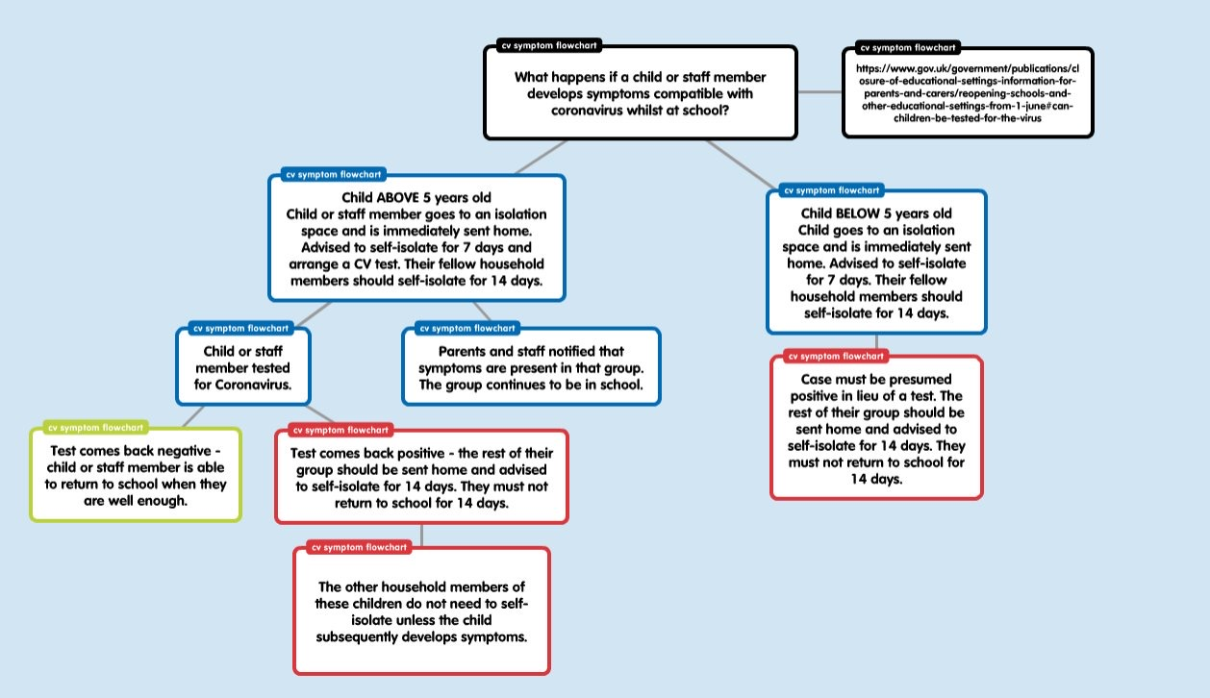

The plan above is not comprehensive and I am sure adjustments will have to be made and these will be communicated with you. Any questions please email them to contact@sleafordchurchlane.lincs.sch.uk.

Kind regards

Mr C Clay

