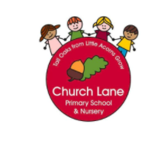
EYFS Curriculum
2022-2023
Intent

At Church Lane Primary School and Nursery we offer a tailor made curriculum that supports the 7 Areas of Learning stated in the ‘Statutory framework for the early years foundation stage.’ We do this by starting from the child- what do they already know? What do they want to discover? Where do they need to go next?

Our overall aim is to ensure every child progresses through each area of learning at their own pace, building on their next steps to ensure they achieve their Early Learning Goals by the end of Reception.

The Prime Areas:
- Personal, Social and Emotional Development
- Communication and Language
- Physical Development
The Specific Areas:
- Literacy
- Maths
- Understanding of the World
- Expressive Arts and Design

To ensure our children become competent and confident learners and achieve their full potential we will offer an ambitious, broad and language-rich curriculum. Our curriculum will have a blended approach where ‘in the moment planning’ (tailored to interests and next steps) runs alongside our planned curriculum (what we want our children to learn to succeed).

Books/poems/rhymes
Skilled practitioners & engaging learning environments
Planned
Curriculum
ITMP
Our highly skilled practitioners will also:

- Provide a playful learning environment that provides the balance of adult led and child-initiated activities through the interests of individual children. We strongly believe that opportunities for interest-based learning accelerates progress due to high levels of engagement.
- Provide a carefully planned curriculum that runs alongside our interest- based provision e.g Seasons/Different cultures and Religions/key aspects of child development
- Offer real life experiences that build cultural capital (what children already know).
- Provide a progressive curriculum that also focuses on key life skills.
- Develop a well-rounded child by ensuring all areas of learning have an equal importance.
- Ensure building blocks are in place so every child is ready for their next step of their journey e.g. Nursery to Reception and Reception to Year 1.
- Build on next steps in the moment- this is key for every child to progress and achieve.
- Targeted support for children with SEND, Pupil Premium and EAL.
- Provide a language rich environment through our love for story books, poems and songs. This is paramount to ensure children foster a love of life-long reading and knowledge is supported through the books we read.
- Areas of Learning will be underpinned with a variety of story books.
- Ponder, wonder, question, challenge, facilitate are just a few teaching strategies that will be used across EYFS. These interactions will ensure children are stretched and moved on in their learning.
- Ensure the ‘Characteristics of Effective Teaching and Learning’ are fully embedded through our engaging, open-ended and creative learning environments.
- Encourage children to set their own goals
- Promote our school values through our daily routines.

To ensure progression and consistency across school we have also planned our EYFS curriculum to ensure our children begin to understand social movement from an early age.

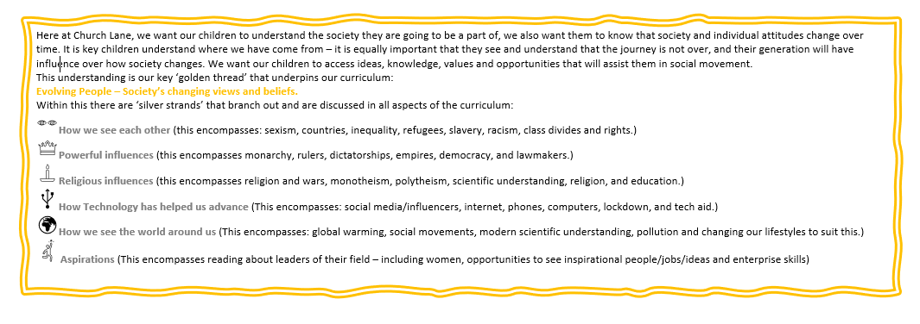

Our life skills goals are golden threads that are woven throughout our whole EYFS curriculum.
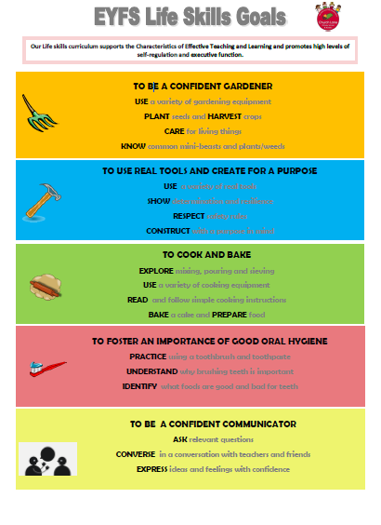

Why? Our children often start Nursery below where they should be with speaking and listening skills. We also have an increasing number of children who have English as an additional language and often start Nursery and Reception with no English. Being a confident communicator is fundamental to success in all areas of learning and future academic ability.

Why? In our area, tooth decay is on the rise in young children. We believe that fostering an importance of good oral hygiene at an early age with have a positive impact on the health of our teeth and mouth. Dentist appointments can be difficult to book since the pandemic, so educating our families is essential.
Why? Our families have suggested they would like to see baking and cooking on our curriculum as they do not always have time to bake and cook with their child at home and/or finances to buy fresh ingredients. We recognise that cooking and baking supports healthy food choices for our teeth and body.
Why? Our children often start Nursery below where they should be with their physical skills. We understand the importance of developing gross motor skills to further develop fine motor skills, ready for writing and building stamina. Using real tools also promotes and encourages an element of risk which is essential when building resilience.
Why? We recognise that many of our families do not have their own gardens or space to take experience nature. Our curriculum allows children to take care of plants that they have grown and living things found in our gardens.

