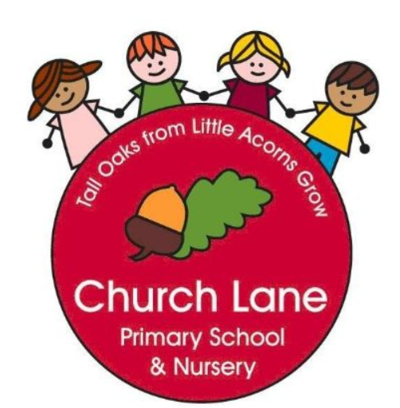 EYFS Curriculum: Literacy
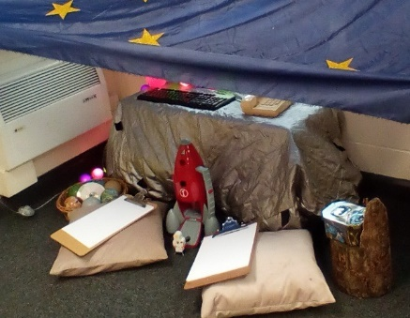
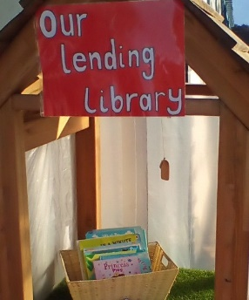
What does this look like across the EYFS?
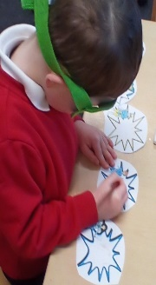
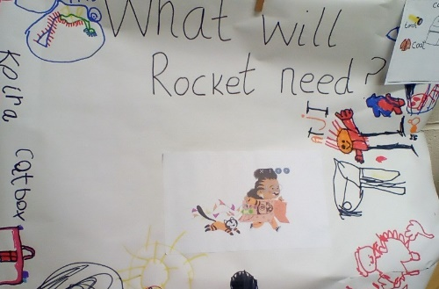
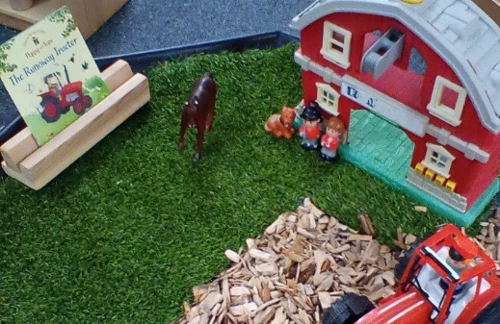
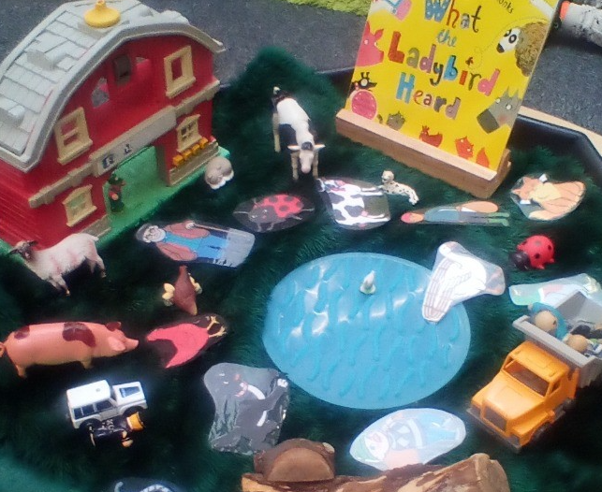
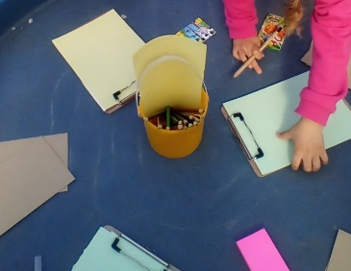
Our Educational Programme:
At Church Lane Primary School and Nursery we believe in developing a life-long love of Reading. Every child in Nursery receives weekly story books to take home and share with their family. In addition to a weekly reading book, family and friends have access to our mini-library that is located in the outdoor area. Books, poems and rhymes are fundamental to our curriculum across all areas of learning. We will enjoy a variety of stories, non-fiction books, poems and rhymes to support language comprehension and word reading. In Nursery, we ensure all the pre-requisites are taught to ensure the children have the best start when they move onto the RWI Phonics scheme and The Literacy Curriculum.We will deliver Reading workshops to parents and ensure books are accessible to all our families and become part of their everyday routine too.
Below is our ambitious curriculum which shows progression across EYFS through the teaching of a variety skills and knowledge, including rich vocabulary. As our children move through the EYFS, the curriculum is designed to ensure all children develop the desired building blocks to ensure they have all the skills and knowledge needed to access National Curriculum. We will use the planned knowledge and skills as a guide (not rigid and not an exhaustive list) throughout the year and will adapt accordingly depending on cohort needs, interests and any gaps in learning.
Communication and Language is at the heart of the curriculum.

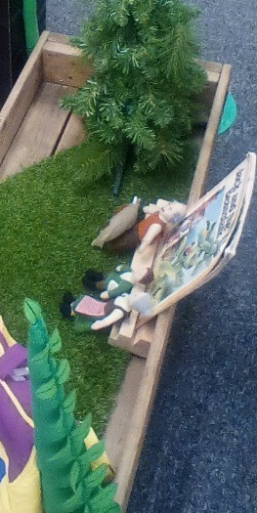

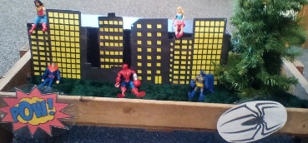
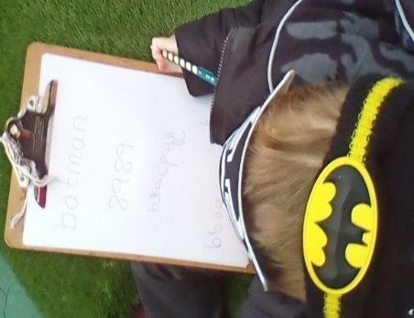
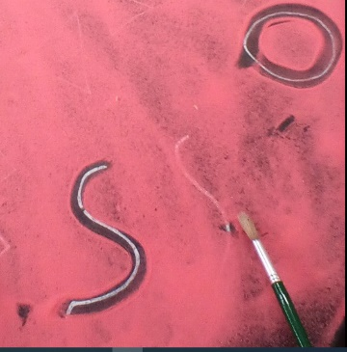
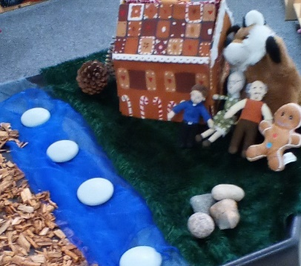
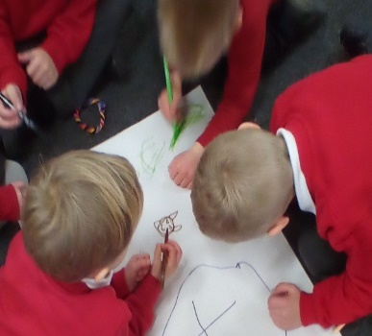
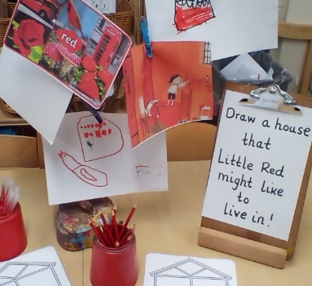
Progression document
National Curriculum links: English
 | Nursery will have a weekly book focus but will be selected depending on cohort needs, interests, vocabulary and other areas of learning | End of year Goals (School Readiness) | Reception: Book Focus |  | End of term check points
Autumn 1 | Writing  To make marks inside and outside Word Reading and Comprehension  To join in with nursery rhymes  To join in with Poems  To recognise own name  To be aware of sounds made by musical instruments, environmental sounds |  | 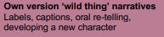  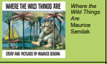  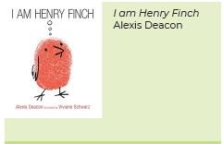  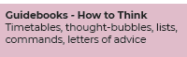 | Writing  To begin to write recognisable letters  To recognise own name and attempt to write it  To orally rehearse sentences  To write initial sounds  Word Reading and Comprehension  To read a wide range of books for pleasure  To set 1 sounds and oral blend  To read CVC words  To develop and learn new vocabulary  To begin to infer what characters are like  To begin to predict  To listen and discuss a wide range of texts | Are they making attempts to write own name?  Can they form some recognsibale letters?  Can they hear and write initial sounds?  Can they recognise all set/most 1 sounds?  Are they beginning to oral blend?
Autumn 2 | Writing  To make marks inside and outside  Word Reading and Comprehension  To join in with nursery rhymes  To join in with Poems  To recognise own name  To be aware of sounds made by musical instruments, environmental sounds |  | 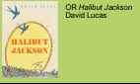  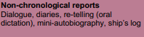  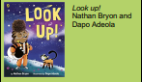  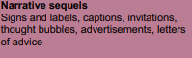 | Writing  To write recognisable letters and CVC words  To recognise own name and attempt to write it  To orally rehearse sentences  Word Reading and Comprehension  To read a wide range of books for pleasure  To read ‘special friends’  To read CVC words  To develop and learn new vocabulary  To begin to infer what characters are like  To begin to predict  To listen and discuss a wide range of texts  To sequence and re-tell | Can they form more recognisable letters?  Can they write CVC words with support?  Can they write their name?  Can they read all Set 1 sounds?  Can they orally blend?
Spring 1 | Writing  To make marks inside and outside  To begin to copy some letters from name  Word Reading and Comprehension  To join in with nursery rhymes  To join in with Poems  To recognise own name  To understand rhyme and alliteration  To begin to understand that a book has a front cover, author and page number |  | 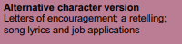  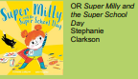  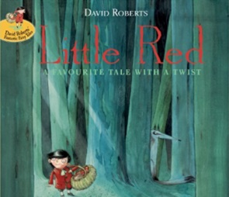 | Writing  To write simple phrases  To independently write own name  To orally rehearse sentences  Word Reading and Comprehension  To develop and learn new vocabulary  To read a wide range of books for pleasure  To consolidate Set 1 sounds  To read simple phrases  To understand that reading texts involves reading from left to write  To begin to infer what characters are like  To begin to predict  To ask and answer questions  To begin to explain my favourite words and phrases  To listen and discuss a wide range of texts  To sequence and re-tell | Can they write CVC words independently?  Are they beginning to write a simple sentence with support?  Is letter formation improving?  Can they blend sounds to read words?  Are they close to being able to read Ditties?
Spring 2 | Writing  To make marks inside and outside  To begin to copy some letters from nam  Word Reading and Comprehension  To join in with nursery rhymes  To join in with Poems  To recognise own name  To understand rhyme and alliteration  To begin to understand that a book has a front cover, author and page number |  | 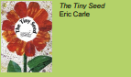  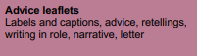  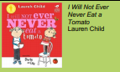  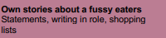 | Writing  To write simple phrases/sentences  To oral rehearsing of sentences  To spell some red words correctly  To write for different purposes  Word Reading and Comprehension  To begin to read simple phrases  To begin to retell events/stories  To begin to sequence events  To begin to predict  To ask and answer questions  To explain links between different stories  To begin to explain my favourite words and phrases  To listen and discuss a wide range of texts  To begin to infer what characters are like  To learn set 2 sounds | Can they write a simple sentence with some support?  Are they beginning to spell red words correctly?  Are most letters formed correctly?  Can they read red books or close to being at red level?
Summer 1 | Writing  To make marks inside and outside  To write name using name card  To begin to write some recognisable letters  To make meaningful marks e.g shopping lists  Word Reading and Comprehension  To join in with nursery rhymes  To join in with Poems  To begin to understand that a book has a front cover, author and page number  To understand that reading texts involve reading from left to right  To begin to understand oral blending  To begin to understand ‘who’, ‘what’ and ‘where’  questions  To begin to understand ‘why’ questions  To begin to ask more questions  To begin to give answers to questions  To recognise some set 1 sounds |  | 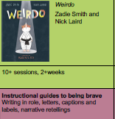  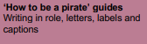  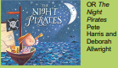 | Writing  To write simple sentences with capital letters and full stop  To form most letters correctly  To Spell some red words correctly  Word Reading and Comprehension  To begin to infer what characters are like  To begin to predict  To ask and answer questions  To begin to explain my favourite words and phrases  To listen and discuss a wide range of texts  To read short sentences | Can they write independent sentences with some red words spelt correctly?  Are they beginning to include capital letters and full stops?  Can they read Green story books or not far off?  Can they read some Set 2 sounds?  Are nearly all letters formed correctly?  Are they beginning to use finger spaces and write on a line?
Summer 2 | Writing  To make marks inside and outside  To write name using name card  To begin to write some recognisable letters  To make meaningful marks e.g shopping lists  Word Reading and Comprehension  To join in with nursery rhymes  To join in with Poems  To begin to understand that a book has a front cover, author and page number  To understand that reading texts involve reading from left to right  To begin to understand oral blending  To begin to understand ‘who’, ‘what’ and ‘where’  questions  To begin to understand ‘why’ questions  To begin to ask more questions  To begin to give answers to questions  To recognise some set 1 sounds  To indenitfy all mnemonics in set 1 | - To write name  - To write some letters accurately developing correct pencil grip  - To engage in extended conversation  - To learn new vocabulary  - To recognise initial sounds  - To oral blend confidently  - To recognise all Set 1 mnemonics  - To recognise some Set 1 sounds  - To make marks for a purpose e.g. shopping lists | 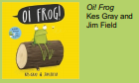  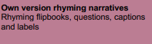  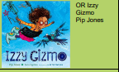 | Writing  To write simple sentences with capital letters and full stop  To write all letters correctly  To begin to use conjunctions and some adjectives to add interest to sentence.  To spelling taught red words correctly  Word Reading and Comprehension  To begin to infer what characters are like  To begin to predict  To ask and answer questions  To begin to explain my favourite words and phrases  To listen and discuss a wide range of texts  To independently read short stories | Can they write one or more sentences with red words spelt correctly?  Are they using a capital letter and full stop?  Are they using finger spaces and writing on a line?  Are nearly all letters formed correctly?  Are they able to read green or purple books?  Early Learning Goal  - Say a sound for each letter in the alphabet and at least 10 digraphs  - Read words consistent with their phonic knowledge by sound-blending  - Read aloud simple sentences and books that are consistent with their phonic  knowledge, including some common exception words.  - Demonstrate understanding of what has been read to them by retelling stories  and narratives using their own words and recently introduced vocabulary  - Anticipate – where appropriate – key events in stories  - Use and understand recently introduced vocabulary during discussions about  stories, non-fiction, rhymes and poems and during role-play.  - Write recognisable letters, most of which are correctly formed  - Spell words by identifying sounds in them and representing the sounds with a  letter or letters  - Write simple phrases and sentences that can be ready by others.

