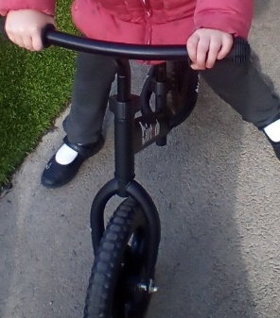
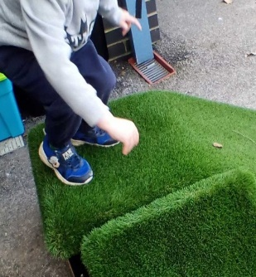
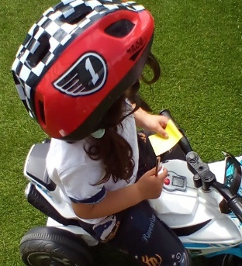
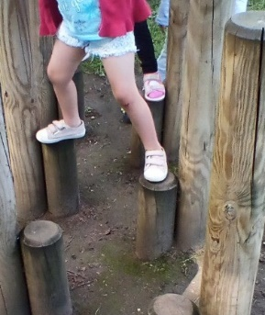
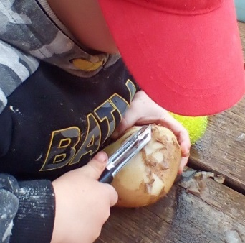
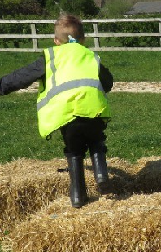
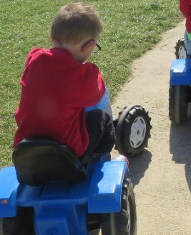
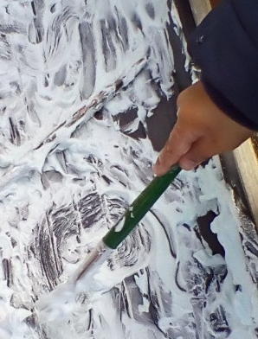
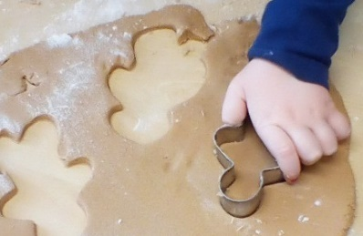
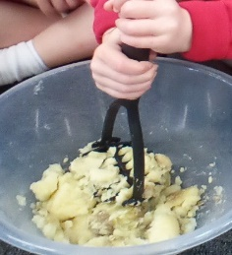
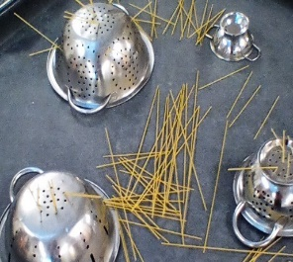
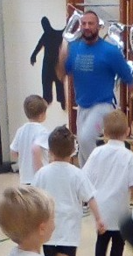
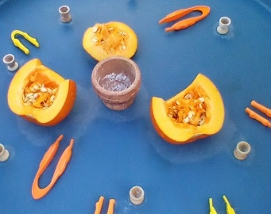
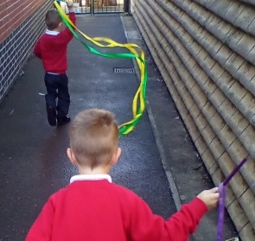
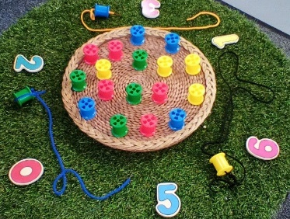
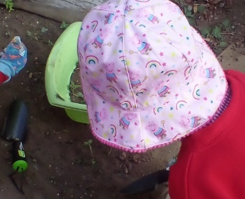
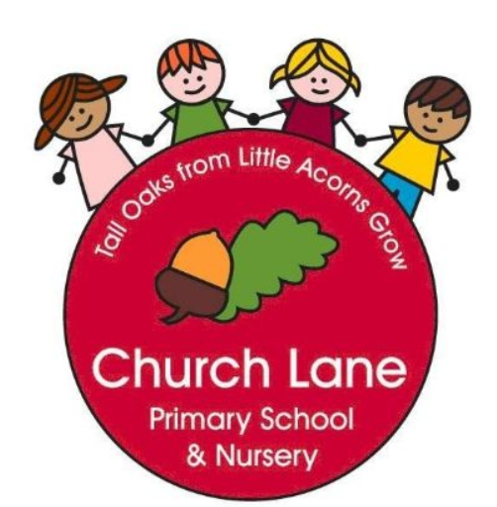 EYFS Curriculum: Physical Development
Our Educational Programme:
At Church Lane Primary School and Nursery we value the importance of Physical Development in the Early Years. We believe that strong bodies are essential for healthy, strong minds and eventually the ability to read and write. In Nursery, we have a new outdoor space that has been carefully designed to physically stretch all children. The children will develop their core strength through climbing, crawling, jumping building and riding a wide range of wheeled toys including balance bikes. Our Nursery take full advantage of the hall space and large field by using them daily to allow the children to move and be physically active. In Reception, our outdoor space ensures progression and further challenge through our vast gardening opportunities, different levels and large construction resources, including a woodwork area to further develop fine motor skills. Our children finally learn to successfully hold a pencil and leave Reception being confident writers, healthy, strong and confident movers.
Below is our ambitious curriculum which shows progression across EYFS through the teaching of a variety skills and knowledge, including rich vocabulary. As our children move through the EYFS, the curriculum is designed to ensure all children develop the desired building blocks to ensure they have all the skills and knowledge needed to access National Curriculum. We will use the planned knowledge and skills as a guide (not rigid and not an exhaustive list) throughout the year and will adapt accordingly depending on cohort needs, interests and any gaps in learning.
Communication and Language is at the heart of our curriculum

Progression document
National Curriculum links: P.E
 | Nursery | End of year Goals (School Readiness) | Reception | End of term checkpoints
Autumn 1 | Gross Motor Skills  How can I move my body in different ways?  -Continue to develop different movements e.g. balancing, riding and ball skills  -Play musical statues and pose e.g. hop, skip, stand on one leg  -Use large movements to wave flags and streamers, paint and make marks  -Develop core muscles  Revise and refine the fundamental movement skills they have already acquired:  • rolling • crawling • walking • jumping • running • hopping • skipping • climbing |  | Gross Motor skills  Games  How do we improve our individual games skills?  How do you know when to start and stop moving in a game?  Gymnastics  How can I move around in different ways?  Movement skills:  -Move freely and with confidence, in a range of ways (hopping, crawling, skipping, running, walking)  How can I move around the space?  What direction can I move in?  What body parts can I travel on?  Fine Motor skills  -Getting changed for P.E with support  -Using Knife and Fork correctly  -Putting on coat  -Chunky pencils to write/salt trays –letter formation | - Can I run safely and change speed and direction to keep me safe?  - Can I move freely with confidence?  - Can I slither, shuffle, crawl, walk, run , jump and skip?  - Can I alternate feet when mounting stairs?  - Can I stand momentarily on one foot?  - Can I dress/undress with maybe some help?
Autumn 2 | Gross Motor Skills  How can I move my body in different ways?  -Begin to match physical skills to tasks e.g decide whether to run, walk, crawl along planks  -Take part in music activities and move body accordingly  Develop core muscles  Revise and refine the fundamental movement skills they have already acquired:  • rolling • crawling • walking • jumping • running • hopping • skipping • climbing |  | Gross Motor Skills  Games  How do we improve our individual game skills?  What can I do with a bean bag? How can I move a bean bag?  - Moving with a bean bag, balancing on different body parts, passing through legs, moving round legs, pushing/sliding on floor, kicking, throwing high/low.  What can I do with a hoop? How can I move a hoop?  - Moving with a hoop, balancing on different body parts, step into hoop, move hoop over head, skipping with a hoop, turning hoop around waist/arms/legs, rolling hoop along floor, walk/run alongside a moving hoop.  Can I get a bean bag into/through a hoop?  - Aiming a bean bag at a hoop on the floor, throwing a bean bag through a hoop held in the air, throwing a bean bag through low basketball hoops.  Can I move a bean bag to a target?  Aiming a bean bag at cones/gates, throwing a bean bag through a low basketball hoop, throwing bean bags into a bucket.  Dance  How can we move to music?  How can I move my body in different ways?  How can I move to music?  How do I know what speed to move in?  How can I copy dance movements?  Fine Motor skills  -Getting changed for P.E with support  -Using Knife and Fork correctly  -Putting on coat on and fastening zip with support  -Chunky pencils to write/salt trays –letter formation | - Can I catch a large ball?  - Can I look after equipment?  - Can I begin to throw a beanbag and a ball using underarm and overarm?  - Can I copy a simple dance routine?  - Can I look, listen and follow simple verbal, body signals and instructions?
Spring 1 | Gross Motor skills  How can I move my body in different ways?  -Develop core muscles  Revise and refine the fundamental movement skills they have already acquired:  • rolling • crawling • walking • jumping • running • hopping • skipping • climbing  Learn some vocabulary related to movement- gallop, slither, follow, lead, copy |  | Gross Motor Skills  Games  How do we improve our individual game skills?  How can I throw a bean bag?  How can I throw a bean bag to a partner?  - Throwing in the air, throwing along a line, throwing into a hoop/bucket, throw under arm, throw over arm, throw through legs, throw over shoulder.  - Throwing to a partner/adult.  How can I catch a bean bag?  How can I catch a bean bag from a partners throw?  - Throw and catch individually, catch from an adult, catch from a partner, catch using cones to make hands larger if needed.  Gymnastics  How can I move around in different ways?  How can I move around the equipment?  What direction can I move in?  What body parts can I travel on?  How do I climb safely?  How do I jump and land safely?  Fine Motor skills  -Independently getting changed for P.E  -Using Knife and Fork correctly  -Putting on coat and fastening zip  -Chunky pencils to write –letter formation | - Can I throw a beanbag to a partner?  - Can I demonstrate different ways to throw a beanbag  - Can I confidently catch a beanbag?  - Can I move around equipment safely?  - Can I confidently climb equipment?  - Can I Jump and land safely?
Spring 2 | Gross Motor skills  How can I move my body in different ways?  -Develop core muscles  Revise and refine the fundamental movement skills they have already acquired:  • rolling • crawling • walking • jumping • running • hopping • skipping • climbing  Learn vocabulary to describe movement and direction |  | Gross Motor Skills  Games  How do we improve our individual game skills?  How can I throw a ball?  How can I throw a ball to a target?  - Throwing in the air, throwing along a line, throwing into a hoop/bucket, throw under arm, throw over arm, throw through legs, throw over shoulder. Throwing to a partner/adult. Bounce on the floor, bounce off the wall, bounce in a hoop, bounce and hit a target.  How can I catch a ball?  How can I catch a ball from a partners throw?  - Bounce and catch individually, bounce a ball to a partner to catch, throw to a partner to catch, catch from an adult throw.  Dance  How can we move to music?  How can I move to music?  How can I copy dance movements?  How can I create shapes in dance?  How can I express my feelings through dance?  Fine Motor Skills  -Independently getting changed for P.E  -Using Knife and Fork correctly  -Putting on coat and fastening zip  -Thin pencils-letter formation | - Can I throw a ball to a target?  - Can I throw a ball in different ways?  - Can I catch a ball on my own and with a partner?  - Can I begin to move to music?  - Can I start to express my feelings through dance?
Summer 1 | Gross Motor skills  How can I move my body in different ways?  Revise and refine the fundamental movement skills they have already acquired:  • rolling • crawling • walking • jumping • running • hopping • skipping • climbing  Learn vocabulary to describe movement and direction  Fine Motor  -Encourage Tripod grip |  | Gross Motor Skills  Games  How do we improve our individual game skills?  How can I use a bat?  - Talk about how to hold a Tennis racket/bat – one handed, using dominant hand, same action as shaking hands.  - Balance bean bags on a bat, add movements – e.g. walking, running. Game idea – Traffic lights, relay races.  - Use a bat to push a beanbag along whilst walking/running. Challenge – push through a series of gates (cones) Follow a set path/route around the space.  - Balance small ball on a bat, add movements - . walking, running. Game idea – Traffic lights, relay races.  - Use a bat to push a ball along whilst walking/running. Challenge – push through a series of gates (cones) Follow a set path/route around the space.  How can I use a bat to make on object move?  - Use the bat to aim the ball to a target – gates, cones, small goals etc.  - Use the bat to aim the ball to a partner. Push to a partner without a bat and with a bat. Can you stop the ball, by only using your bat?  - Push the ball along the floor back and forth with a partner – rally.  - Bounce the ball on the floor and hit it with the bat.  - Challenge – hot a ball that is thrown to them (bouncing in front)  Gymnastics  How can I move round in different ways?  What different body parts can I move on? (Floor and equipment)  What different body parts can I balance on?  Can I balance on equipment?  What different shapes can I make with my body? How do I hold the shape still?  What shapes can I make on the equipment?  Fine Motor Skills  -Independently getting changed for P.E  -Using Knife and Fork correctly and chopping effectively  -Putting on coat and fastening zip  -Thin pencils—focus on letters being the same size | - Can I begin to use a variety of bats in different ways?  - Can I explore using my body in different ways?  - Can I begin to make shapes using my body?
Summer 2 | Gross Motor skills  How can I move my body in different ways?  Revise and refine the fundamental movement skills they have already acquired:  • rolling • crawling • walking • jumping • running • hopping • skipping • climbing  -Practice getting changed for P.E and join in with some P.E sessions in the hall  Fine Motor  -Encourage Tripod grip | - To get changed independently  - To put my own coat on and fasten using the zip  - To begin to use tripod grip consistently  - To begin to write letters anti-clockwise  - To negotiate space | Gross Motor Skills  Athletics  How can I prepare for Sports Day?  How do I run in a race?  How do I work as a team?  How do I run a relay race?  Dance  How can we move to music?  How can I move to music using ribbons/streamers?  How can I copy dance movements?  How can I create shapes with ribbons/streamers in dance?  How can I express my feelings through dance, using ribbons/streamers?  Fine Motor Skills  -Independently getting changed for P.E  -Using Knife and Fork correctly  -Putting on coat and fastening zip  -Thin pencils-letter size the same and encouraged to write on a line | Early Learning Goals:  Gross motor Skills:  Negotiate space and obstacles safely, with consideration for themselves and others;  - Demonstrate strength, balance and coordination when playing;  - Move energetically, such as running, jumping, dancing, hopping, skipping and climbing.  Fine Motor Skills:  Hold a pencil effectively in preparation for fluent writing – using the tripod grip in almost all cases;  - Use a range of small tools, including scissors, paint brushes and cutlery;  - Begin to show accuracy and care when drawing.

How will we support Physical Development?
Nursery:
Continuous Provision | Enhancements | Adult-led
Nexus Pegs to Paper  Tricycles  Balance bikes  Pedal vehicles  Climbing frame with slide and tunnel  Large wooden blocks for obstacle courses  Dough  Pouring  Stirring  Spray bottles  Scooping  Puzzles | Threading  Dancing with scarves  Dressing/undressing dolls  Tweezers  Pegs | Daily Field time x2 a day  Access to outdoor area during CP time  Access to school hall- Yoga, Equipment

Reception:
Continuous Provision | Enhancements | Adult-led
Dough/clay  Woodwork  Pouring  Stirring  Spray bottles  Planting and caring for plants  Playing with small world toys  Construction kits  Creating obstacle courses  Den Making  Wheelbarrows  Balls/games  Large and small equipment  Puzzles  Tricycles | Nexus Pegs to Paper  Threading  Dancing with scarves  Dressing/undressing dolls  Tweezers | NEXUS Pegs to Paper  Dough Disco  X2 hours of P.E per week  Morning wake up, shake up  Balance bike time  Daily letter formation  Writing at tables to ensure correct posture  Access to outdoor garden during CP time  Play times

