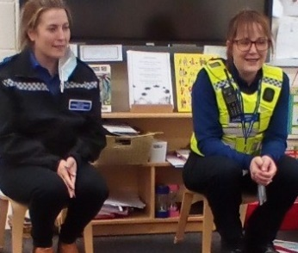
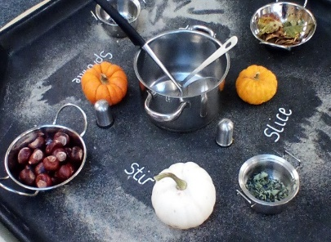
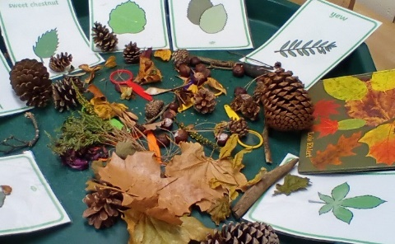
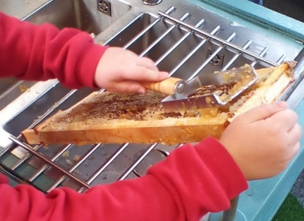
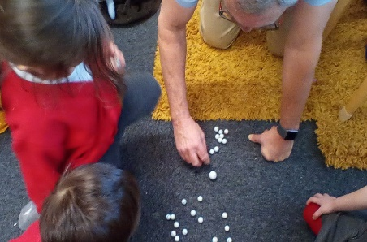
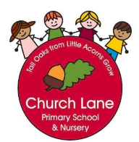
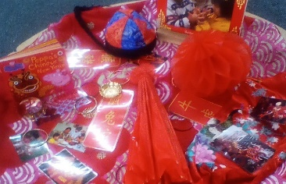
EYFS Curriculum: Understanding of the World
What does this look like across EYFS?
Our Educational Programme:
At Church Lane Primary School and Nursery we will guide our children to make sense of their world around them by planning and teaching a variety of skills, knowledge and vocabulary. We will visit the local area in Sleaford including Sleaford Library, The Hub, Sleaford Mill, Market Place and Sleaford Mosque. We will invite a variety of visitors into school to expand our awareness of important members of our society. We will also use our parents and wider family members to introduce new skills and knowledge to us. These connections will support our understanding of our diverse world. All learning will be underpinned with memorable experiences and a wide range of books, rhymes and poems. The children will have daily opportunities to talk about the weather and to observe seasonal changes. We use Purple Mash to enhance our curriculum with computing skills. To ensure all children can retrieve knowledge, we set weekly rainbow challenges that focus on previously taught learning. At the end of each half term, we take part in a class quiz to recall knowledge and to see what has been remembered. To ensure progression we plan a sequence of lessons starting in Nursery and Reception- please see our ‘Sequence of Learning’ document.
Below is our ambitious curriculum which shows progression across EYFS through the teaching of a variety skills and knowledge, including rich vocabulary. As our children move through the EYFS, the curriculum is designed to ensure all children develop the desired building blocks to ensure they have all the skills and knowledge needed to access National Curriculum. We will use the planned knowledge and skills as a guide (not rigid and not an exhaustive list) throughout the year and will adapt accordingly depending on cohort needs, interests and any gaps in learning.
Communication and Language is at the heart of our curriculum

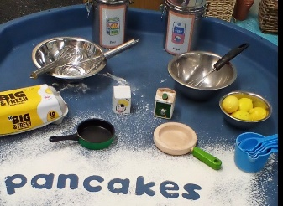

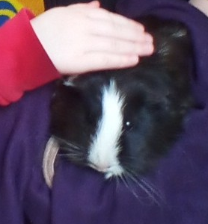

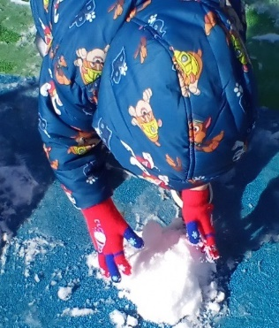
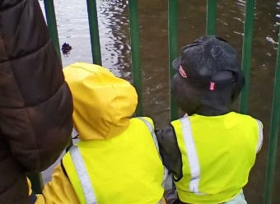
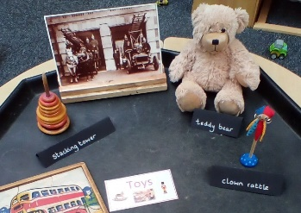
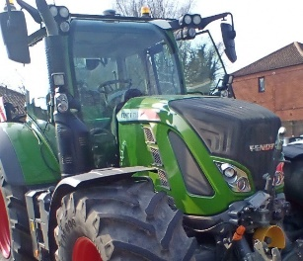
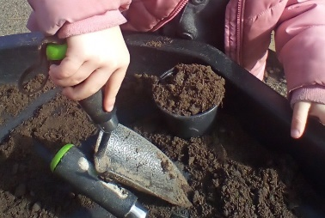
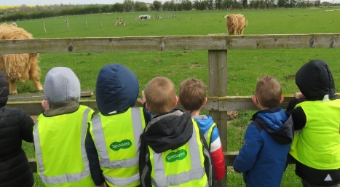

Progression of knowledge document
National Curriculum links: Geography History R.E Science Computing
 | Nursery | End of year Goals (school readiness) | Reception | End of term check points
Autumn 1 | Focus: Community work  Past and Present  Did I visit any of these places over the summer?  Recognise places in Sleaford that they might have visited over the summer and sequence events  Begin to talk in the past tense and role model  What do I look like?  Use mirrors to begin to identify facial feature and body parts  The Natural World  What can I see and hear in Sleaford?  Find and recognise local places in Sleaford and landmarks- train station, The Hub, Library, Mill, allotments  Visit Tesco, local shop and market to compare similarities and differences  Know how to buy ingredients from the market to cook or bake  Experience visiting a café in Sleaford and learn how to place an order  Discover a Polish shop and listen to different language used  People, Culture and Communities  Who is in my family? Who is special to me at home?  Learn names of different family members  Find out who is in my family  Talk about things that they do with Mum/Dad that are special to them  What can I see and hear in Sleaford?  Meet members from a Mosque and Church and begin to talk about different religion  Observe seasonal changes  Meet important members of our community  Identify some adaptions in Sleaford that support disabilities e.g. guide dog, Braille  Observe different technology in a convenient shop compared to Tesco |  | Focus: Our world  Past and Present  What did I do over the summer?  Recognise that when I am talking about the summer holidays/Nursery experiences it is in the past  Talk about experiences using photos on Tapestry to support discussion  Use language and photos to sequence events  How have I changed from being a baby to now?  Learn how we change from a baby to a child  Recognise some of the similarities and differences from when they were a baby compared to a child  Talk about own features e.g. colour of hair/eyes  The Natural World  Where did I go over the summer?  Learn how to find where we live on a map  Discover Google Earth  Place other towns/cities/countries on the map  Locate school on the Sleaford map and other points of interest e.g. park, supermarkets  Where do I live?  Use Google Earth to navigate around different streets  Learn our address and why it is important to know it- emergency services, posting letters  Purple Mash: Explore Simple City  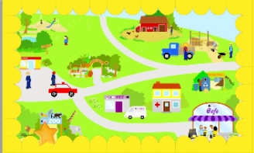  People, Culture and Communities  Which people are special to me? Who do I look up to?  Recall family member names  Talk about people who are special to them including themselves, friends, people in community and people associated to religious origins  What special jobs do some people do?  Meet important people members of our society  Find out who can help us when we need help and why  Learn the roles of a police officers, nurses and firefighters  Learn the emergency services number  Purple Mash: Mashcams  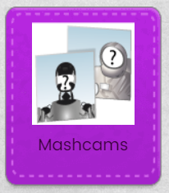  Who is Jesus and why is he special?  Learn that Jesus is seen as the role model for people who follow the Christian religion  Discover a story of Jesus performing a miracle and talk about what he did that was special | Can I talk about my immediate family and member of my community?  Can I talk about some places that are special to me and members of my community?  Am I beginning to understand the past and talk freely about past events?  Am I aware how I have changed since being a baby?  Can I talk about my summer?  Can I talk about some of the important people in my community?
Autumn 2 | Focus: Celebrations  Past and Present  How do I celebrate Christmas?  Discover out how their friends prepare and celebrate Christmas  Learn about special foods and special places that I might visit or visited in the past  The Natural World  What do I notice in autumn?  What is different in autumn- environmental changes  What am I wearing to Nursery now  What can I find on the floor in autumn  What can I see, feel, smell and hear  People, Culture and Communities  What is Diwali?  Provide information about Diwali festival  Identify different cooking styles and methods  What do I notice at Christmas time?  Learn some Christmas carols and perform to a Residential home  Re-visit Sleaford and notice seasonal changes- Christmas lights, decorations |  | Focus: Autumn changes  Past and Present  Which special people have there been in the past?  Perform our own Christmas Nativity  Learn about Mary, Joseph and Jesus and why these religious figures are special  The Natural World  What are some of the key changes in autumn?  Identify and notice what they can see outside  Learn about why leaves fall from trees and identify some common leaves  What do we need to wear in autumn  Learn about different materials used for warm clothing  Use senses to describe what we can feel, smell, hear and see  Purple Mash: Autumn paint project  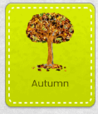  How do animals prepare for winter?  Identify which animals prepare to hibernate  Learn what squirrels, hedgehogs and birds do to prepare  Find out why some animals hibernate  Learn what hibernation is  Purple Mash: Hedgehog paint project  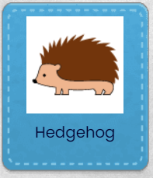  People, Culture and Communities  Why is Diwali special?  Recap what Diwali is and recall previous knowledge  Identify the special role of Diwali within Hinduism  Discuss some similarities and differences with familiar celebrations  What is the Christmas Story?  Learn about the importance of Christmas in the Christian calendar  Discuss our own family traditions and favourite stories  Understand that some stories have particular importance to people of faith (the Bible is important for Jews and Christians)  Purple mash: Christmas jumper paint project  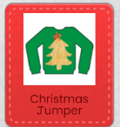  Computing: Technology in our lives  Identify some technology that is used in school, at home and in everyday life  Use Ipads safely  Use safe apps to play and learn | Can I talk about what I can hear, see and feel outside?  Can I make observations of the effect of changing seasons?  Can I talk about the difference between summer and autumn?  Can I name some of the important religious figures in the Nativity story?  Do I understand how some animals prepare for winter?  Do I recognise that people have different beliefs and celebrate special events in different ways?
Spring 1 | Focus: Intergenerational  Past and Present  What did I do over Christmas?  Use Tapestry to recall Christmas events  Role model using past tense when sharing experiences  What is special about my grandparents/great-grandparents?  Identify immediate and some extended family members  Explore special times with grandparents/great-grand parents  Find out if any grandparents have skills e.g. carpentry, knitting, cookery  Learn some new skills from grandparents/great-grandparents  The Natural World  What do I notice in winter?  Explore what is different in autumn- environmental changes  Identify what I am wearing in Nursery  Go for a walk around Sleaford- What can I see? What can I feel?  People, Culture and Communities  What is Chinese New Year?  Identify the animal that is linked with the year of their birth  Discover the story of the Chinese New Year (CBeebies animation)  Talk about how does it feel when you win in a race or come last in a race?  Take part in Chinese New Year style celebrations |  | Focus: Winter and cold places  Past and Present  How was my Christmas different or similar to my friends?  Use Tapestry to recall Christmas events  Discuss similarities and differences  Use past tense  How do my toys look different from my grandparent’s toys?  Explore toys from the past  Learn about what materials toys were primarily made of and why  Discuss similarities and differences  Purple Mash: Old Toys pairs game  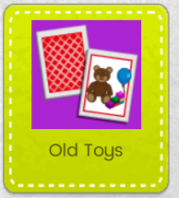  The Natural World  What are some of the key changes in winter?  Use photos of garden from the different seasons and compare  Discuss why we need to wear different clothes compared to the summer  Talk about animals in winter  Uses senses to describe what we can see, hear, feel and see  Learn about the change in state- ice melting and water freezing  Discover how we can speed up ice melting  Purple Mash: Paint Projects  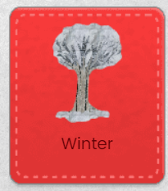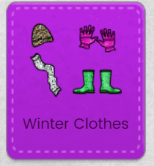  Is Sleaford as cold as other places in the world?  Locate Antarctica and Arctic on a 2D map and on a 3D globe.  Use Google Earth to locate as well  Discuss how we would travel there  Learn facts about Penguins and Polar Bears  Compare similarities and differences with life in Sleaford to life in the Arctic and Antarctica  People, Culture and Communities  Who helps look after our roads in the winter to keep us safe?  Discover the role of people who help us keep the roads and paths safe in winter  Why is Chinese New Year important in the Chinese calendar?  Discover the story of the Chinese New Year  Re- tell the story, remembering the main events  Discover how families celebrate Chinese New Year  Purple Mash: Chinese Lion Paint project  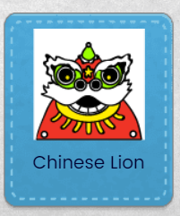  Computing: E-Safety  Understand that I have ask an adult to use the internet and that I must tell an adult if something is worrying me.  Understand what the internet is used for and why.  Understand why it is important not to have too much screen time.  Learn how to be careful when using technology devices. | Have I developed my knowledge and understanding of how people celebrate special events in different ways?  Do I compare toys from the present and the past?  Do I continue to develop my understanding of the changing season?  Can I draw information from a simple map?  Do I recognise some similarities and differences between life in this country and life in another country?
Spring 2 | Focus : Planting  Past and Present  What did I do over Half-term?  Talk about what I did over half term using photos on Tapestry  What is a tractor used for and who uses them?  Discover inside and outside of a tractor  Meet a Farmer and begin to ask questions about his/her role.  The Natural World  What can I see? What do I dislike/like about spring?  Using photos talk about spring.  Identify some key features of spring  Go for a walk and discover any signs of spring  Use cameras to take photos.  Learn that spring is a season that is all about new life and growth  Discover signs of spring through books, walks and garden observations  Introduce life cycles  What do I need to grow a plant from seed?  Discover the tools/resources needed to grow a plant  Plant fast growing plants e.g. cress and compare to s slower growing plant e.g. sunflower  Learn about decay over time  Talk about the daily/weekly changes  People, Culture and Communities  What happens at Easter?  Identify some symbols of Easter e.g. Easter egg, Jesus, church, lamb, bunny  Find out what each other likes about Easter and why Easter is special  Discover how each other celebrate Easter using parents to support through Tapestry |  | Focus: Farming and food  Past and Present  How was farming transport different in the past?  Learn how farming equipment helps farmers sow the seeds and harvest the crops  Discover old and new tractors  Learn about the Horse and Cart  Embed that the past has already happened  Recap Harvest learning  The Natural World  Where are farms found?  Locate Sleaford on Google Earth./map  Locate a local farm and talk to the Farmer via video link  Compare Sleaford area with a contrasting environment e.g. Farming in Africa  Purple Mash: Simple City Farm  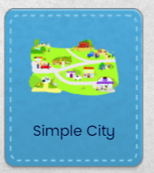  What are baby animals called?  Discover farm animals and offspring names  Sort out farm animals and wild animals  Learn what animals are born in spring  Purple Mash: Baby animals matching game  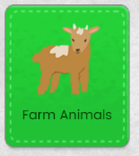  Where does my food come from?  Sort out fruit and vegetables  Learn about how farm animals provide us with essential food e.g. milk, dairy products, eggs, meat  What are the signs of spring? How has our garden changed?  Uses senses to describe the changes that indicates spring including nature and wildlife  Take photos of changes they can see  Identify some common plants and flowers now in garden/local area  What does a seed need to germinate?  Plant a variety of seeds and compare sizes  Recap what a seed need to germinate and how and what plant seeds to grow strong and healthy  People, Culture and Communities  What is the role of a Farmer?  Learn that a Farmer can be male or female  Discover Farmers from around the world  Learn why Farmers are important people of different communities  What is Easter?  Identify and sort Easter symbols and non- Easter symbols  Discuss: What do you already know about Easter? What makes Easter special? Who is Easter special to?  Discover each others own experiences of Easter  Why is Easter so important to Christians?  Listen to the Easter story  Describe how the story makes us feel  Refer back to the symbols of Easter and relate them back to the story.  Understand that hot cross buns represent Jesus’ death and chocolate eggs represent him coming back to life again  Purple Mash: Design an Easter egg  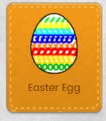  Computing: Multimedia  - Use iPad to move objects on screen  - Use a paint app to create shapes and text on a screen  - Use KIT to take photos and to share learning | Have I developed my knowledge and understanding on how things have changed from the past to present?  Have I developed my knowledge and understanding on how to draw information from a simple map?  Can I name some names of common offspring?  Can I talk about where my food comes from?  Do I continue to develop my understanding of the changing season?  Can I talk about what a plant needs to grow?  Have I developed my knowledge and understanding on how people have different beliefs and celebrate special events in different ways?
Summer 1 | Focus: Recycling /Reusing  Past and Present  What do I notice about the objects from the past?  Discover every day collections from the past e.g. cameras and old telephones/mobiles  Talk about the past making links with their personal experiences and knowledge  Make connections with old photographs and cameras from the past  Describe how the cameras/phones work and the different parts  Introduce language linked to how old the camera/phone is relating it to the ages of people they are familiar with  The Natural World  What minibeasts can we find in the garden and how can we create look after them?  Identify some common minibeasts  Explore why they are found in certain habitats  Learn how to make a minibeast hotel  Sort out appropriate materials to re-use  Discover different materials and learn new vocabulary to name to the materials  What is the Lifecycle of a Butterfly?  Discover the lifecycle of a butterfly first- hand  Learn how to keep them alive  People, Culture and Communities  What can we re-use to support local community?  Explore clothing banks/bottle banks in the community  Explore a charity shop and the importance of them  Talk about different bin colours that they might have at home and the purpose  Discover clothing from different cultures |  | Focus: Minibeasts and habitats  Past and Present  What is the role of a Beekeeper?  Learn why Beekeepers are important members of our society  Discover the role of a Beekeeper  How are our gardening tools different to those from the past?  Discover gardening tools from the past using Mrs Smiths Loans box  Purple Mash: Simple City- Garden Centre  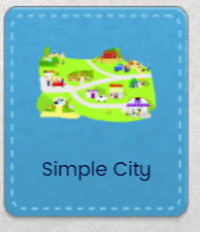  The Natural World  What is an insect?  Identify a variety of minibeasts found in the garden and record findings  Discover what an insect is and identify some in the garden  Learn facts about different insects e.g. beetles, butterflies and bees  Purple Mash: Grouping Minibeasts  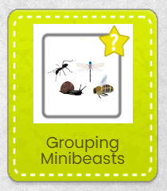  Why do we need to look after bees?  Learn facts about bees  Find out why Bees are important  Discover how to encourage Bees into gardens at home  Learn how honey is made and use senses to taste, smell and feel  Do butterflies lay eggs?  Learn facts about caterpillars and butterflies  Discover/recap the lifecycle of a butterfly first- hand  Describe each stage of the life cycle and the changes that occur  People, Culture and Communities  What is Ramadan? What is Eid al- Fitr?  Learn how some of our Muslim families take part in Ramadan and celebrate Eid  Learn that Ramadan is the most important month in the Islamic calendar  What is the moral of the story? Why are books important?  Discover the story of ‘The Boy who cried wolf’  Learn what a ‘moral’ and ‘fable’ is.  Describe the feelings of the villagers and the boy  Discover the story of ‘The Tortoise and the Hare.’  Describe the feelings of the tortoise/hare at the beginning and the end of the race  Learn that all books are important sources of information and should be handled with  care and respect  Computing: Handling Data  - Identify different kinds of information such as pictures, video, text and sound. | Have I developed my knowledge and understanding on how things have changed from the past to present?  Can I describe lifecycles and understand the key features?  Do I continue to develop my understanding of the changing season?  Do I understand why books are important?  Have I developed my knowledge and understanding on how people have different beliefs and celebrate special events in different ways?  Do I understand why it is important to look after living things?
Summer 2 | Focus: New adventure  Past and Present:  How have I changed since starting Nursery? (For children who are moving to Reception)  Explore pictures on Tapestry and discuss how they have changed from when they first started  What am I looking forward to doing next?  Talk about any summer holiday plans- ask parents too  Explore places they could visit  Prepare children for journey to Reception  The Natural World  What is a shadow?  Explore making shadows outside and talk about how shadows occur  What objects sink? What objects float?  Explore sinking and floating  Visit River Slea and explore sinking and floating  People, Culture and Communities  Who is my new teacher going to be? (For children starting school)  Talk about new teacher and schools and begin to establish new relationships | - To talk about what they see using a wide range of vocabulary  - To understand some of their own history and their family’s history  - To show interest in people who are important in our community  - To understand how to look after living things including plans and wildlife  - To talk about what they notice  - To understand that there are different countries in the world  - To respect other people including similarities and differences | Focus: Explore  Past and Present  What are the different modes of transport?  Learn that the different modes are air, water and land transport  Learn which mode of transport will be more suited for travelling to different places around the world  Purple Mash: Matching transport to destination  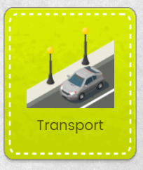  How has transport changed over the years?  Learn how buses and aircraft have changed over the years  Discover photos from the past relating to different transport  Who was Emilia Earhart?  Explore Emilia Earhart and why she is famous  Learn that women and men can fly aircrafts  Look at photos of her aircraft- How do we know it is an old photo?  The Natural World  What is a map?  Learn what a map is  Follow a simple map to find treasure around the school  Follow a simple map to find a place in Sleaford  Learn how to draw a variety of maps, identifying some simple features  Purple Mash: Create an Island Map  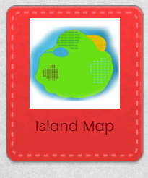  Where is London?  Learn about some of the famous landmarks in London  Learn that London is the Capital City of England  Discover that the Queen used to live in Buckingham Palace  Use Google Earth to explore London  Purple Mash: London Bus paint  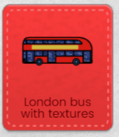  Can shadows only be seen outside?  Explore making shadows inside and outside using different light sources  Re-cap what a shadow is and how they are made  Is it only large items that sink?  Investigate large/small items made from different items  Sort into groups  Discuss materials and properties  People, Culture and Communities  What makes houses special?  Discover different styles of houses from around the world  Understand how our houses are all different and unique  What makes a place special to me and others?  Describe special places that they might visit with family and why is it special  Discover iconic places from around the world  Learn why these places are special and who would visit  Understand that we all have different special places  Who is a Church special to?  Talk about who the Church is special to  Locate Churches in Sleaford  Discover what parts are special in the Church and why  Who is a Mosque special to?  Talk about who a Mosque is special to  Locate Sleaford Mosque  Discover what parts are special in a Mosque and why  Learn about the rules that Muslims have to follow when going into a Mosque- link it back to school rules  Computing: Programming  Programme a Bluebot and make it move in different ways  Understand that I can make choices about the buttons and icons I press, touch or click on | Past and Present ELG  Children at the expected level of development will:  -Talk about the lives of the people around them and their roles in society  -Know some similarities and differences between things in the past and now, drawing on their experiences and what has been read in class  -Understand the past through settings, characters and event encountered in books read in class and storytelling  People Culture and Communities ELG  Children at the expected level of development will:  -Describe their immediate environment using knowledge from observation, discussion, stories, non-fiction texts, and maps  -Know some similarities and differences between different religious and cultural communities in this country, drawing on their experiences and what has been read in class  -Explain some similarities and differences between life in this country and life in other countries, drawing on knowledge from stories, non-fiction texts and – when appropriate – maps  The Natural World ELG Children at the expected level of development will:  -Explore the natural world around them, making observations and drawing pictures of animals and plants  -Know some similarities and differences between the natural world around them and contrasting environments, drawing on their experiences and what has been read in class  -Understand some important processes and changes in the natural world around them, including the seasons and changing states of matter

Procedural knowledge document
 | Nursery | Reception
Past and Present | - Begin to use the past tense to explain events that have happened in the past  - Begin to understand events from the past that are relatable to me | - Recount events that have happened during my lifetime  - Use the past tense to explain events that happened in the past  - Use pictures and stories to ask questions about the past
People, Culture and Communities | - Begin to notice differences and similarities. | - Ask family members about their job roles.  - Why am I unique?
The Natural World | - What do we want to know?  - What do we see?  - Where do I live?  - Where can I go on holiday?  - Begin to use a map to identify different places | - What do we want to know?  - What do we notice?  - Locate England on the map/globe and other countries that we are learning about or from the books we have read  - Understand what a map is  - Use a simple map to travel from A to B  - Begin to draw own maps inspired by stories e.g. Treasure maps, maps to show a journey  - What does a plant need to grow?

Possible planned enhancements
Nursery: Autumn 1
Continuous Provision | Memorable experiences | Key Vocabulary | Books/Poems to explore
Photos of different families  Map of Sleaford  Market/café role play  Fruit and Vegetables to chop- sensory tray  Chop vegetables and cook soup  Drawing/Painting of people who are special to them  Harvest related activities | Visit Mosque and Church  Visit Fire Station  Meet emergency service workers  Walk around Sleaford and visit:  Art Hub, Mill, variety of shops  Order and eat in a café  Bake and cook using ingredients brought from market  Visit local foodbank and donate food  Invite family member in for a stay and play session | Mosque  Church  Local landmark vocab e.g. supermarket, café  Food bank  Fruit  Vegetables  Family member names | We’re Going on a Bear Hunt  Goldilocks and the Three Bears  Books related to families  The Runaway Tractor  Pumpkin Soup  Farmer Duck  My Granny went to the Market  Poetry Basket- Falling apples

Reception: Autumn 1
Continuous Provision | Memorable experiences | Key Vocabulary | Books/Poems to explore
Self-portraits  Emergency services dressing up clothes  Maps of Sleaford and places of interest  Small world figures-people who help us and multi-cultural figures  Globe  Building emergency service vehicles | Families from different cultures to be invited in and talk about family dynamics  Photos of own families  Mrs Smith’s Loan box  Walk around Sleaford  Visits from Emergency Services | Long ago  Past  Special  Present  Remember  Family  Map  Emergency services  Recent  When you were a baby…  Courageous  Kind  Role model  Special times  Jesus | The Colour Monster  The Colour Monster goes to school  Owl Babies  Big Hair Don’t Care  Happy in our skin  All about families  Pete the Cat Rocking in my New School Shoes  Bible story- Story of Jesus healing the paralysed man  Bible story- Story of Jesus healing the blind Bartimaeus (Mark 10: 46-52)  Real Superheroes  Life savers  Poetry Basket-shoes

Nursery: Autumn 2
Continuous Provision | Memorable experiences | Key Vocabulary | Books/Poems to explore
Christmas decorations  Christmas related activities  Diwali related activities  Autumn sensory trays- natural objects  Woodland animals | Re-visit residential home in Sleaford and sing some Christmas Carols  Invite parents in for Christmas crafts  Walk around Sleaford to explore seasonal change e.g. Christmas, autumn changes  Lincoln Fun Bus | Fallen  Colours  Season  Change  Christmas  Celebrate  Senses | Little Owl and the Star  Dream Snow  The Gruffalo  Room on the Broom  First facts: Seasons  Peppa Pig: Diwali  Poetry Basket- Breezy weather

Reception: Autumn 2
Continuous Provision | Memorable experiences | Key Vocabulary | Book/Poems to explore
Woodland creatures  Natural resources-pine cones, conkers  Autumn clothes  Christmas and Diwali artefacts  Leaf identifications charts | Autumn walk- collection bags  Christmas Nativity  Boston Pantomime  Visitor from Hedgehog nurse  Now>Press>Play- Christmas Story  Diwali celebration day  Church visit  Bring in own special books- why are they important to us? | Hibernate  Day  Night  Seasons  Autumn  Family tradition  Special times  Diwali  Senses | Wide awake Hedgehog  The Squirrels Busy Year  Little Red Riding Hood  Seasons  The Wind Blew  The Leaf Man  Let’s celebrate: Festival poems from around the world  The Christmas Story  Poetry Basket- Leaves are falling

Nursery: Spring 1
Continuous Provision | Memorable experiences | Key Vocabulary | Books/poems to explore
Cooking Chinese food e.g. stir fry  Add Chinese New Year cooking equipment to home corner  Pictures of Grandparents board | Inviting Grandparents into school and learning some new skills  Cooking Chinese food  Tasting Chinese food | Celebrate  Winter  Language linked to senses  Great-grandparents  Grandparents  Chinse New Year | Books about Grandparents  Peppa Pig and Chinese New Year  Shark in the Park on a Windy Day  Stickman  Poetry Basket- I can build a Snowman

Reception: Spring 1
Continuous Provision | Memorable experiences | Key Vocabulary | Books/poems to explore
Christmas photo board  Old and new toys  Ice experiments  Polar Bears and Penguins  Chinse New Year enhancements | Now>Press>Play: weather  Old toys artefacts  Sleaford museum visit  Chinese New Year celebration day | Celebrate  Old  New  Not so old  Modern  Materials  Chinese New Year  Special Occasion | One Day On our Blue Planet: In Antarctica  Animals in Winter  Stick Man  Secrets of Winter: Emperors Egg  Lost in the Toy Museum  Kippers toy box  Poetry Basket- Lets put on our mittens

Nursery: Spring 2
Continuous Provision | Memorable experiences | Key Vocabulary | Books/poems to explore
Spring sensory trays  Magnifying glasses  Planting equipment  Recipe books in home corner  Easter crafts | Easter crafts with parents  Local spring walks  Baking  Tractor visit  The Gingerbread man Now>Press>Play | Spring  Life cycle  Easter  Recipe Cards  Seed  Farmer | Jack and the Beanstalk  Superworm  Jaspers Beanstalk  Wake up, Its Spring!  Spencer knows Spring  Little Bears Spring  The very hungry Caterpillar  Farmer duck  We’re going on an Egg hunt  Poetry Basket-Mrs Bluebird

Reception: Spring 2
Continuous Provision | Memorable experiences | Key Vocabulary | Books/poems to explore
Life cycle puzzles  Farm animals  Planting resources  Germination models  Recipe books  Play dough  Easter crafts | Tesco Farm to Fork  Farm Kitchen workshops  Tractor visits/Farmer visits  On the Farm- Now>Press>Play  Bread making  Planting/chitting potatoes  Video link with a local farmer  Visit Farmers market  Monthly Library visits  Sunflower competition  Easter service at Church | Chitting  Germinate  Easter  Jesus  Offspring  Life Cycle  Spring  Senses vocab  death | Chickens are not the only ones  Little Red Hen  Handa’s Surprise  Oliver’s Vegetables  What the Ladybird Heard  Tractors-non fiction book  Mrs Wishy Washy’s Farm  The Easter Story  Lola plants a garden  Poetry Basket- A Little Seed

Nursery: Summer 1
Continuous Provision | Memorable experiences | Key Vocabulary | Books/poems to explore
Materials for children to sort  Butterfly large floor puzzle  Magnifying glasses/bug pots  Minibeast investigation trays | Set up a recycling centre in class  Visit clothing banks/charity shop  Butterfly house  Make a minibeast hotel  Visit from NKDC to talk about recycling | Reuse  Recycle  Recycling  Lifecycle and vocab linked to each stage  Habitat  Past language | What the Ladybird Heard  The Very Hungry Caterpillar  Twist and Hop to the Minibeast Bop  Peepo  Poetry Basket: Sliced Bread

Reception: Summer 1
Continuous Provision | Memorable experiences | Key Vocabulary | Books/poems to explore
Lifecycle puzzles  Butterfly house  Magnifying glasses  Flower and plant identification sheets  Minibeast record sheets  Art resources outside  Islam resources | Now>Press>Play Jack and the Beanstalk  Minibeasts  Visit to Art Hub- gallery  Butterfly house  Mrs Smiths Cottage loans box- gardening tools  Bee keeper visitor  Monthly Library Visit  Bee café | Moral  Fable  Lifecycle  Insect  Beekeeper  Chrysalis  Egg  Pollen  Nectar  Ramadan  Eid al-Fitr  Habitat  Old  New  Not so old  Modern  Materials | TAD  Yucky worms  The Bee Book  A Butterfly is Patient  Camille and the Sunflowers  Jack and the Beanstalk  Life Cycles: seed to a sunflower  The Very Hungry Caterpillar  Superworm  Tell me more about Ramadan  The Boy who cried wolf  Poetry Basket: I Have a Little Frog

Nursery: Summer 2
Continuous Provision | Memorable experiences | Key Vocabulary | Books/poems to explore
Sinking and floating  Shadows | Transition sessions  Sinking and Floating at River Slea  Art Hub visits | Shadow  Light dark  Sink/float  Journey | We’re going on a Lion Hunt  Three Billy Goats Gruff  I am absolutely too small for starting school  The Tiger Who Came to Tea  Poetry Basket: Own choice (choose one to sing at Graduation)

Reception: Summer 2
Continuous Provision | Memorable experiences | Key Vocabulary | Books/poems to explore
Creating shadows  Letter writing templates  London landmarks  Christianity and Islamic resources  Under the Sea resources  Different maps  Map making resources  Maps/Globes  Torches/dark tents  Sinking/Floating opportunities | Summer trip  Transitions into Year 1  Now>Press>Play Transport  Now>Press>Play Seaside  Visit church  Visit Mosque  Library  Make paper aeroplanes  Double Decker bus visit/ride | Ocean  Sea  Land  Transport  Map  Direction  Landmark  Human Feature  Natural Feature  special  sinking/floating  shadows | One Day on our Blue Planet: Oceans/Savannah  Greta Thunberg  Oh the Places you will go  Rosie’s hat  The Naughty Bus  Somebody Swallowed Stanley  Amelia Earhart  The Night Pirates  Paddington at the Palace  The queen’s Hat  Katie in London  Poetry Basket: Under a Stone

