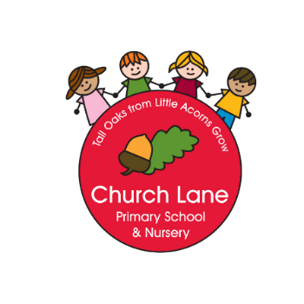
Church Lane Primary School and Nursery
Science Policy
Men love to wonder, and that is the seed of science – Ralph Waldo Emerson
Science gives man knowledge which is power – Martin Luther King Jr
Intent
Our intention at Church Lane Primary School and Nursery is to develop children’s sense of awe and wonder in the world around them. Encouraging them to fully engage in the world and question and investigate what they see. We want our curriculum to be ambitious and we have designed it to give all our children the knowledge and cultural capital they need to succeed in life past primary; giving them the opportunity to aim for a variety of careers.
We will ensure that our intention is met through…
- Providing a broad and robust curriculum for our children to work through which challenges them and stimulates their interest in Science
- Delivering engaging Science lessons that provide the children with regular opportunities to complete practical Science work
- Ensuring our children are aware of how Science applies to their everyday life through texts and stories.
- Giving our children the opportunity to ask their own scientific questions and have an input in to the planning of their experiments.
- Ensuring our children have access to our outdoor learning environment, visits from specialists and local facilities to enhance the delivery of our curriculum and engage our children’s interest.
- High quality and level vocabulary will be introduced in each lesson alongside knowledge which will be built upon through the children’s time in school.
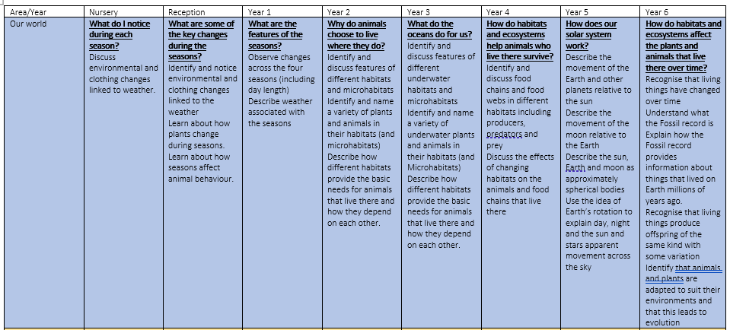
Our curriculum
Our curriculum has been specifically
designed for our school. It focuses on
making Science accessible to our children
and building knowledge and procedures in
a sensible way.
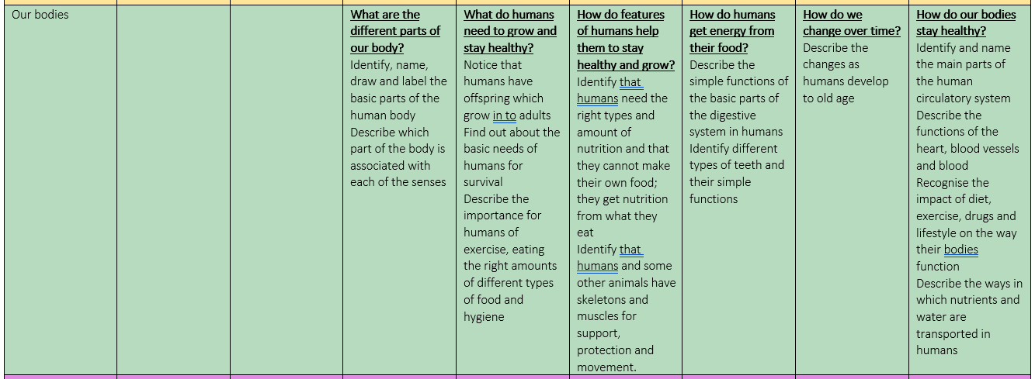
Knowledge progression:

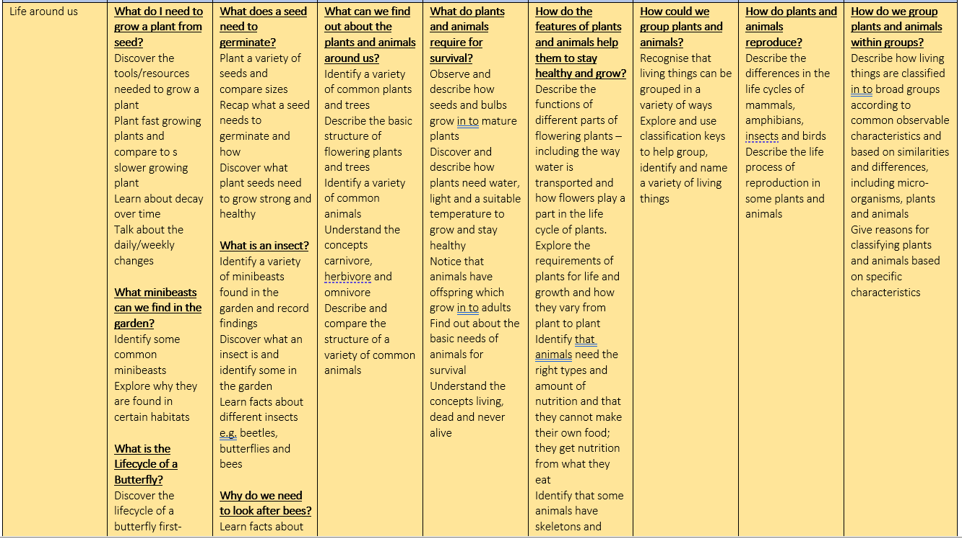

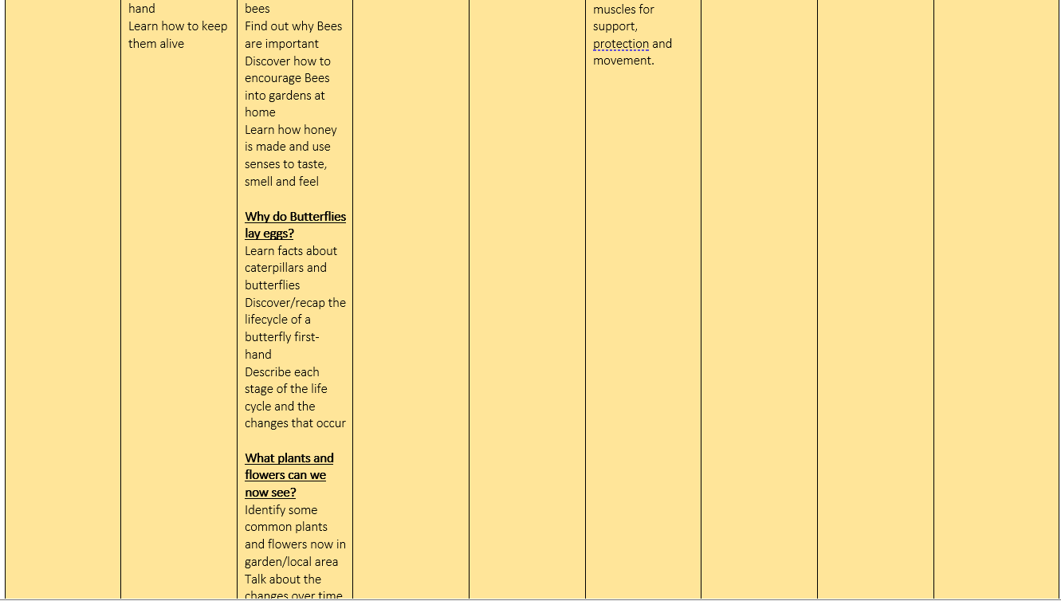

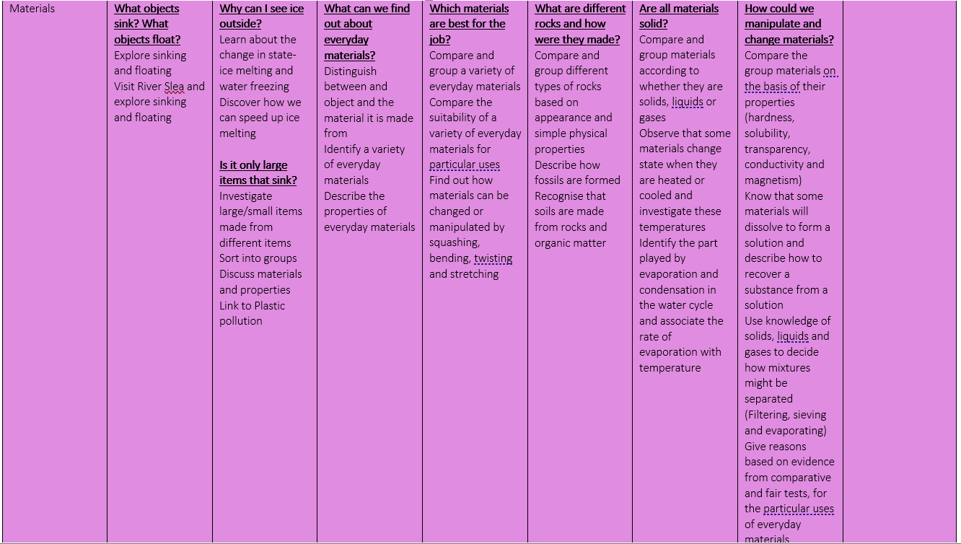

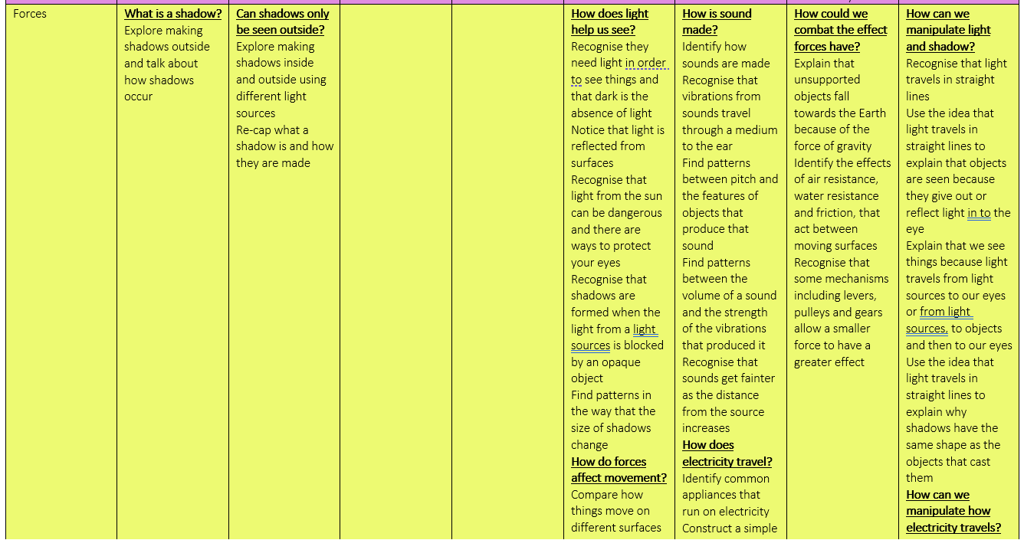

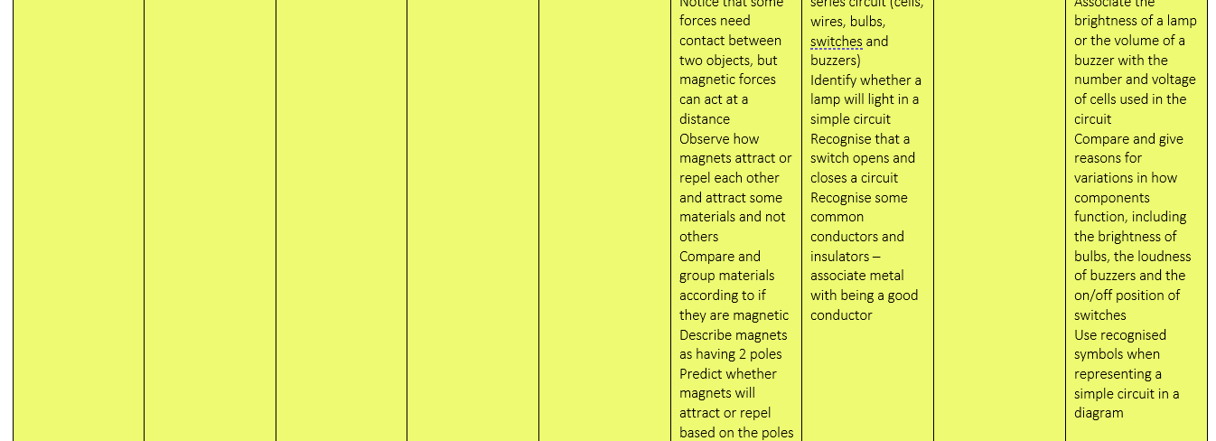

Procedural knowledge:
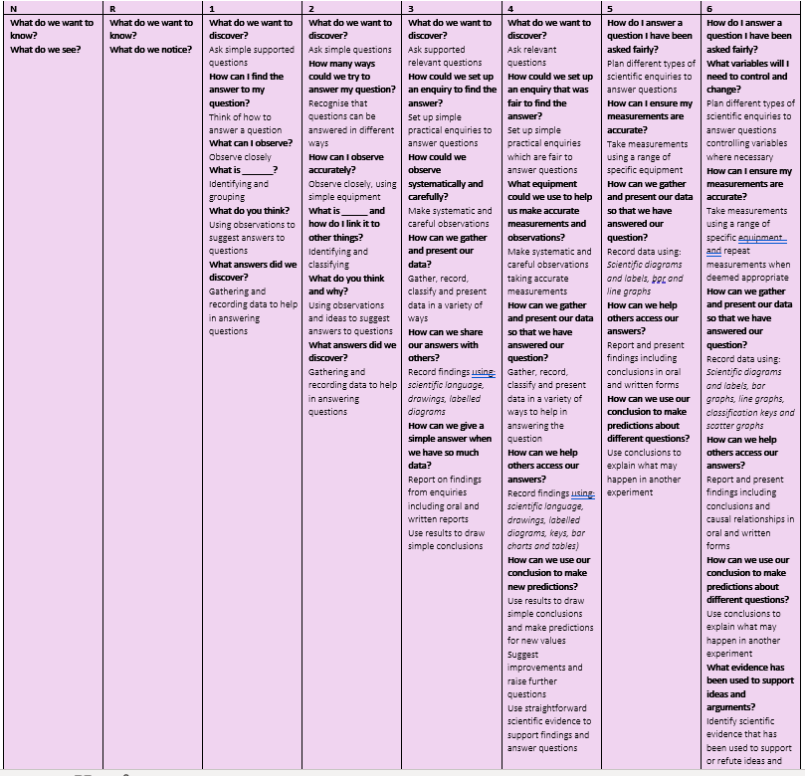
Principles of Teaching
Science is taught throughout the school from EYFS (Where it is covered in ‘understanding the world’) to KS2. All pupils are encouraged to participate in Science lessons regardless of race, culture, gender, ability or physical limitations. We use Science work to support our PSHE and Social studies where we have mutual respect and a sense of ethics behind what we do. “Our Scientific power has outrun our spiritual power. We have guided missiles and misguided men.” Martin Luther King Jr
During Science lessons the children are expected to work in a variety of ways including in groups, as a whole class, in pairs and individually.
There is no set structure to Science lessons at Church Lane but they MUST include the following: a discussion of what Science is; a discussion of what our question is asking us; a small reading task to encourage learning through our own exploration and research; answering the question that has been posed in some way – either through exploration or research and discovery.
Role of the Science co-ordinator
Endeavour to promote a dynamic approach to the teaching of Science so that it is engaging and opens the children’s eyes to the world around them
Provide CPD and advice to staff
Oversee the implementation of the Science Curriculum
Keep up to date with developments through reading and course attendance
Monitor the subject through book looks/ planning/ observations/ children’s voice and data
Co-ordinate extra Science theme days and activities
Assessment, Recording and Reporting
Teachers will assess Science using the Head Start progress tests in Science termly. This data will be inputted in to the I track assessment system at the end of each year.
Policy Reviewed and updated by: R Minucci in August 2023
To be reviewed: August 2024

