KEY FACTS:
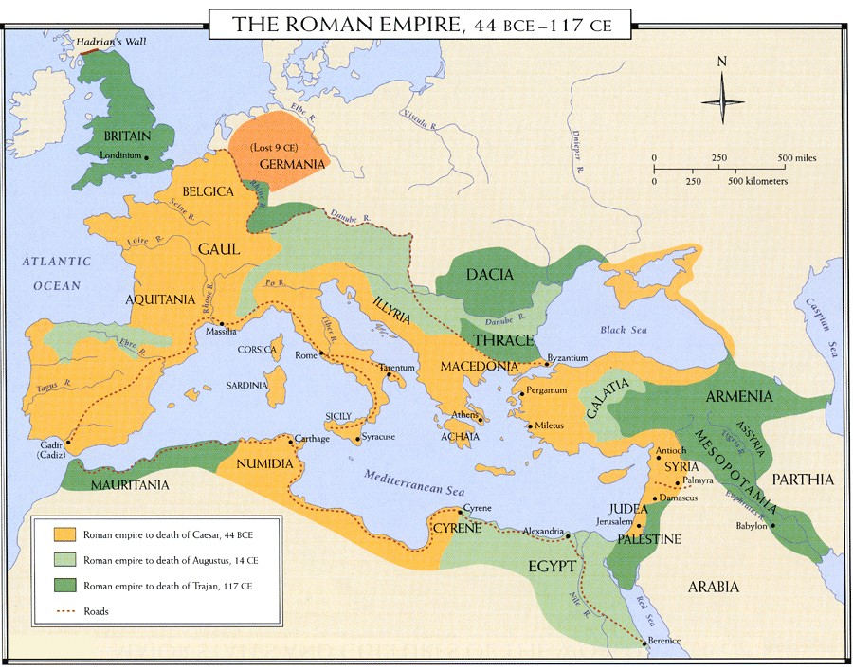
⇒ The Roman Empire covered most of Europe, some of Africa and Asia.
⇒ Britain was invaded twice by the Romans, ﬁrst unsuccessfully and the second time successfully in AD43.
⇒ The Romans created towns in Britain including Londinium (London,), Camulodunum (Colchester), Deva Victrix (Chester) and Lindum (London).
⇒ Famous people from Roman times include Julius Caesar, Emperor Hadrian, Boudicca and the poet Virgil.
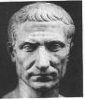
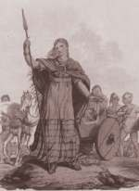
Julius Caesar Boudicca Emperor Constantine
ROTTEN ROMANS
What did the Romans ever do for us?

KEY FACTS:
⇒ Romans are known for their amazing inventions including roads, underﬂoor heating, public baths and aqueducts.
⇒ The Romans ate and drank all sorts of interesting things including dormice in honey and wine with lead in it!
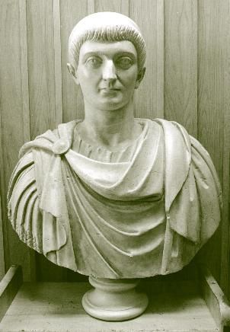
⇒ The Roman army was terriﬁcally well organised, using structure to overpower larger forces. It was also used to keep order in the Empire.

KEY VOCABULARY

amphitheatre
A place like a stadium, where Romans went to watch animals and people fighting.

aqueduct
A system of pipes and channels used to bring water into towns.

barbarian
A person who lived outside the Roman Empire, seen by Romans as violent and uncivilized.

assembly
The Assembly was the public meeting of the government of the city. All citizens could take part and vote there.

capital city
Main city of a country, the centre of government.

catapult
A machine that threw rocks or burning tar at the enemies. In Latin it was called an onager.

cavalry
Soldiers who fight on horseback.

chariot
Cart with two wheels pulled by horses. Romans raced chariots, and Celtic warriors rode into battle on them.

Celts
People who lived in Europe, including Britain, and who fought the Romans.

centurion
An officer commanding about 80 legionaries.

citizen
The stage of human social development and organization which is considered most advanced

election
Process where people vote to choose the people they want to be in charge.

empire
A large area with many people ruled by one strong leader, called an emperor.

fort
A building with walls to keep out enemies, used by soldiers.

general
leader of an army, the soldier giving the orders to everyone else.

gladiator
A person trained to fight other gladiators or animals in amphitheatres.

governor
The ruler of Roman Britain, who worked for the Roman Emperor.

hypocaust
Roman central heating. Hot air from a furnace (fire) flowed through gaps be- tween walls and flooring

Latin
The language spoken and written by the Romans

legion
The main battle unit of the Roman army, its soldiers were called legionaries. There were between 4,000 and 6,000 legionaries in a legion.

legend
A story made up about people in the past

mosaic
A pattern made from coloured pieces of stones and pottery.

myth
A made-up story, often about gods and spirits, told to explain things such as why the sun rises and sets every day.

republic
A country without a king, queen or emperor. The Roman republic was ruled by the elected Senate. Most countries to- day are republics.

scroll
Roman book, written on a long strip of paper rolled around a stick.

senate
The Roman government, made up of senators.

senator
A person elected to the Roman Senate who helped run the government. Some countries today, like the U.S.A., have senators.

sewers
Pipes or tunnels that carry away sewage.

slave
Someone who can be sold to another person to work for nothing. A slave is not free and has no rights.

standard
Roman army emblem, a pole with special decorations (such as a metal eagle) carried by a soldier. Each legion had its own standards.

stylus
A metal pen for scratching words into soft wax on wooden tablets.

taxes
Money or items taken by the government from people, to pay for things like the army, wars, emperor's palaces and building roads.

villa
A large house in the country. Some Roman villas were farmhouses and some were like palaces.

