Safeguarding Newsletter
Focus on: Healthy Gaming
As we move past Christmas, we know that games will have been top of the Christmas list for lots of children. Whilst online gaming can pose a high risk to children if not carefully controlled by parents/ cares, it can also be something to
be enjoyed by children of
ages. Place2Be have created
all
a
great article covering:
- Parental controls
- Playing together
- Watching out for risks
- Healthy balance
- Boundaries
This can be found here:
https://parentingsmart.place2be.org.uk/article/ supporting-healthy-gaming-habits-for-children
Focus on: Injuries
A key part of staff’s safeguarding responsibility in school is looking out for any unusual or unexplained injuries children may present. This is a legal duty of care that all members of staff have as part of their role within school. Whilst we understand that children will often have bumps and scrapes from day-to-day play, more significant or unusual injuries may warrant further questions to be asked. We will always ensure parents/carers are part of these conversations as appropriate, with the sole goal of ensuring children are kept safe at all times.
Term 3 2023
Welcome!
Welcome to Church Lane Primary School and Nursery’s Safeguarding Newsletter. Keeping children safe is of course, our key priority here at school. Safeguarding takes many forms including: Protecting children from harm; preventing impairment of children’s health and development; enabling safe and effective parenting and giving children equal opportunities in life. We do many things every day in school to ensure pupils are safe including: ensuring all staff are trained in safeguarding; having clear policies and procedures in place to keep children safe; monitoring pupil attendance; ensuring a safe and healthy site; ensuring the behaviour of pupils is in line with the Schools behaviour policy and using our curriculum to teach children about risk taking, diversity, healthy lifestyles, managing relationships, online safety and much more. Our safeguarding policy is always available to view via our website.

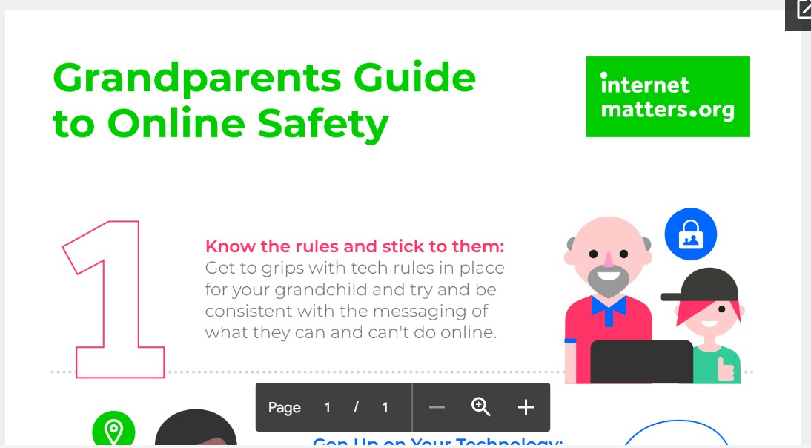
Safeguarding Newsletter
Term 3 2023

Who can help?  Every school has a ‘Designated Safeguarding Lead’. At Church Lane Primary School and Nursery, these are: Mr C Clay, Mrs K Jones, Mrs S Mccordick, Mrs G Blanchard and Mr J Barratt. Our safeguarding governor is Mrs Mel Porter. If you have any concerns in relation to safeguarding, please feel free to speak to a safeguarding lead at any time. |  | Useful phone numbers  Social Services: 01522 782111  ChildLine: 0800 1111  Lincolnshire Prevent Team: 020 7340 7264  Young Carers Helpline: 01522 553275  NSPCC whistle blowing helpline: 08088 005000  FGM helpline: 08000 283550  Samaritans: 01522 528282  Family Services Directory: 0800 195 1635
Online Safety: Grandparents Guide to Online Safety

Many grandparents will be carers for children either in a full time or part time capacity and it is vital that they have a good understanding of the risks and issues faced by children and young people. Internet Matters have put together a fabulous guide for grandparents giving advice on a range of issues such as:
- Screen time.
- Online gaming.
- Managing money.
- Peer pressure.
- and more.

This excellent online guide is available here: https://www.internetmatters.org/ resources/grandparents-guide-to-online-safety/

