Pupil premium strategy statement 2022/23

This statement details our school’s use of pupil premium (and recovery premium for the 2022 to 2023 academic year) funding to help improve the attainment of our disadvantaged pupils.

It outlines our pupil premium strategy, how we intend to spend the funding in this academic year and the effect that last year’s spending of pupil premium had within our school.

School overview
Detail | Data
School name | Sleaford Church Lane Primary School and Nursery
Number of pupils in school | 204
Proportion (%) of pupil premium eligible pupils | 41%
Academic year/years that our current pupil premium strategy plan covers | 2022/23
Date this statement was published | September 2022
Date on which it will be reviewed | September 2023
Statement authorised by | Jason Barratt / Callum Clay
Pupil premium lead | Jason Barratt
Governor / Trustee lead | Barbara Jones
Funding overview
Detail | Amount
Pupil premium funding allocation this academic year | £ 112,185
Recovery premium funding allocation this academic year | £
Pupil premium funding carried forward from previous years (enter £0 if not applicable) | £1,614
Total budget for this academic year | £113,799

Part A: Pupil premium strategy plan

Statement of intent
When making decisions about using Pupil Premium funding it is important to consider the context of the school and the subsequent challenges faced. This alongside research conducted by the EEF. Common barriers to learning for disadvantaged children, can be less support at home, weak language and communication skills, lack of confidence, more frequent behaviour difficulties and attendance and punctuality issues. There may also be complex family situations that prevent children from flourishing. The challenges are varied and there is no “one size fits all”.
We will ensure that all teaching staff are involved in the analysis of data and identification of pupils, so that they are fully aware of strengths and weaknesses across the school.
Our ultimate objectives are:
- To narrow the attainment gap between disadvantaged and non-disadvantaged pupils
- For all disadvantaged pupil at Church Lane to equal or exceed National Expectations for progress
- To ensure the children’s health and wellbeing is supported sufficiently in order for them to access daily learning at the appropriate level
- To give disadvantaged children the best possible and equal experiences to their non-disadvantaged peers.
Principles
- To ensure that teaching and learning opportunities meet the needs of all the pupils
- To ensure that appropriate provision is made for pupils who belong to vulnerable groups, this includes ensuring that the needs of socially disadvantaged pupils are adequately assessed and addressed
- When making provision for socially disadvantaged pupils, we recognise that not all pupils who receive free school meals will be socially disadvantaged
- We also recognise that not all pupils who are socially disadvantaged are registered or qualify for free school meals. We reserve the right to allocate the Pupil Premium funding to support any pupil or groups of pupils the school has legitimately identified as being socially disadvantaged.
- Pupil premium funding will be allocated following a needs analysis which will identify priority classes, groups or individuals. Limited funding and resources means that not all children receiving free school meals will be in receipt of pupil premium interventions at one time.
To ensure we achieve these objectives, the school will:
- Ensure all teaching and learning is good or outstanding by completing learning walks, book looks and teacher/pupil interviews – intervening where necessary.
- Ensure interventions are actioned daily and the interventions are worthwhile and thoroughly planned and thought about.
- Provide pastoral support through the pastoral team, whenever it is needed.
- Ensure Teaching Assistants and Teachers have completed CPD to know how to support pupils in the best possible way.
- Ensuring all our work through the pupil premium is aimed at accelerated progress and ensuring pupils are working at Age Related Expectations.
- Pupil premium resources are to be used to target able children to exceed expectations.
- Pupil premium resources are used to support pupils who need support at various times of the year – not necessarily disadvantaged pupils.
- Support pupils for extra-curricular activities, educational visits and residentials to ensure they have first-hand experiences to support learning in the classroom.
- Use pupil-premium resources to support behaviour throughout school.
This list is not exhaustive and will change according to the needs and support our socially disadvantaged pupils require.

Demography and School Context
Sleaford Church Lane Primary School and Nursery is a local authority run school, in Sleaford, rural Lincolnshire, located in the East Midlands. Each year group is one form entry with 30 in almost every class.
The school has a large pastoral team in response to the vast needs, that our children display.
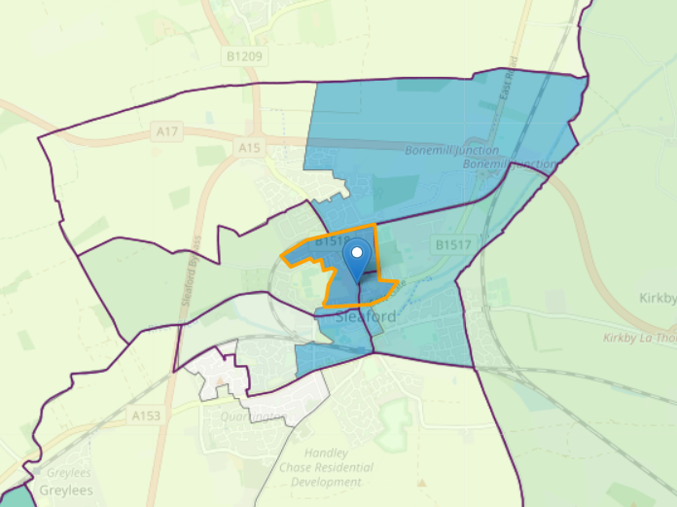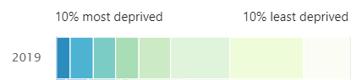
In 2019, the LSOA, which Church Lane Primary School and Nursery is associated with, was ranked 9,067 out of 32,844 LSOAs in England. This is amongst the 30% most deprived neighbourhood in the country. As a school, we feel that this is not a true reflection of the pupil intake at the school. As a school we see large amounts of social and material deprivation. This is reflected in other statistics where Sleaford Church Lane Primary School and Nursery is ranked in the top 20% of the Income Deprivation Affecting Children Index.

Challenges

This details the key challenges to achievement that we have identified among our disadvantaged pupils.
Challenge number | Detail of challenge
1 | Weak Language and Communication skills resulting in Low attainment on entry to the Early Years Foundation Stage in all areas
2 | Larger vocabulary gap between disadvantaged children and non-disadvantaged children
3 | More frequent behaviour difficulties.
4 | Large attainment gap between disadvantaged and non-disadvantaged pupils
5 | Chaotic family lives and Social Service involvement

Intended outcomes
This explains the outcomes we are aiming for by the end of our current strategy plan, and how we will measure whether they have been achieved.
Intended outcome | Success criteria
Progress in Reading | Achieve at least national average progress scores in KS2 Reading (0)
Progress in Writing | Achieve at least national average progress scores in KS2 Writing (0)
Progress in Mathematics | Achieve at least national average progress scores in KS2 Maths (0)
Phonics | Achieve at least national average expected standard
Other | Ensure attendance of disadvantaged pupils is above 96%

Activity in this academic year
This details how we intend to spend our pupil premium (and recovery premium funding) this academic year to address the challenges listed above.

Teaching (for example, CPD, recruitment and retention)
Budgeted cost: £
Activity | Evidence that supports this approach | Challenge number(s) addressed
Pastoral support -permanent member of staff to deal with pastoral support in house as well as safeguarding, parental coaching and attendance. | High percentage of disadvantaged pupils in school with poor attendance, poor mental health, poor physical health warranted the need to a full time pastoral support member of staff. In addition to high proportions of children open to social care.  Pastoral support has an open door policy, where children can go, so that they discuss issues with a trusted member of staff and can be moved back into class to recommence their learning as soon as possible. | 2, 3, 5

Targeted academic support (for example, tutoring, one-to-one support structured interventions)
Budgeted cost: £3150
Activity | Evidence that supports this approach | Challenge number(s) addressed
Phonics support stafff | On entry to Reception, most children have low Language and Communication skills.  The school follows RWI where smaller groups have been created and a slowing down of the curriculum, which meant more staff are needed to allow for more groups. TAs hours were increased and support staff were employed using the Pupil Premium budget to assist in increased attainment data. | 1, 4
Staff for interventions and intervention programmes | CPD used for Support Staff so they can be used to support with Interventions. Interventions now planned daily, with smaller groupings as per the advice from EEF on progression in Interventions with smaller groups. | 1, 4
Experiences | To increase vocabulary in our disadvantaged children, we ensure payment support is available for children to access experiential learning. | 1, 2, 5
Library scheme updated | School increased the books available to children. Disadvantaged children were asked what books interested them, with many being purchased to encourage reading for pleasure. More books were purchased for rewarding reading. The more reading children do, the more chance they have at winning a book of their choice – this is expected to improve attendance as books will be signed daily and only one signature a day. | 1, 3, 4

Wider strategies (for example, related to attendance, behaviour, wellbeing)
Budgeted cost: £
Activity | Evidence that supports this approach | Challenge number(s) addressed
Uniform – purchase of blazers for UKS2 (£2000)  Partial payment of wages for Pupil Premium lead for additional monitoring (£7000) | School purchased children’s first blazers and additional blazers as part of a swap shop scheme to take the strain of families when purchasing required uniform.  Social Services involvement is still high in our disadvantaged families, therefore additional funding for access for pastoral needs is available.  Attendance and Punctuality issues. Attendance figures are currently below the expectation, the monitoring of attendance by PP lead allows for immediate interventions to take place and use of Pastoral team where required.  Governors are updated on the PP trends termly. | 3,4,5
Educational visits/ experiences | Many families are unable to contribute to trips or educational visits, money is then set aside to support these families so that nobody misses out on trips or experiences. | 2, 3, 5
Residential Costs | Most of our pupils only experience time away from home, during the year, on school residentials. It is essential for their own wellbeing that they experience different settings, particularly experiencing some form of independence. Children are offered several educational visits per year but one residential per year – including a trip to Paris, which may be the only time they will ever go abroad.  Y3 residential is to a farm  Y4 residential is to the coast (Norfolk) to experience outdoor education and physical activities mainly working in teams.  Y5 residential is outdoor adventure where they are challenged to push themselves to their limits.  Y6 residential is to Paris | 1,2,3,4,5

Total budgeted cost: £113,799

