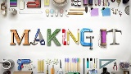  Maker Hour | Build the tallest tower | Build a den in your house or garden | Make a boat to float in your bath | Create a large piece of art | Make a sock puppet | Make your own healthy lunch | Paint a pebble | Draw a picture on a cereal box | Create a board game | Bake a cake
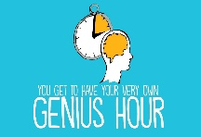  Genius Hour | Play Kim’s Game  (Memory game with a tray of objects) | Learn to read and spell 5 new words | Learn some words in another language | Learn some sign language | Learn a magic trick | Write a rap song | Draw your family and any pets you have | Learn to juggle | Learn to tie a tie | Practise a musical instrument
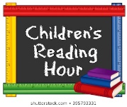  Indi Reading Hour | Find a picture book you never noticed before | Read a recipe or instructions to complete an activity | Read and learn a poem | How many book titles can you read in an minute? Can you improve? | Turn your favourite story into a comic book | Read a description from a book and create your own illustration | Read to someone else in your family for THEIR enjoyment | Time how many words can you read in a minute. Can you improve it? | Read someone else’s favourite book? | Begin to read your favourite book again
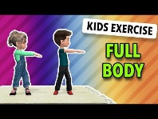  Fitness Hour | Have a disco with your family and dance to your favourite tune | Go on a safe walk with a family member | Make an obstacle course inside and out | Make a fitness workout-Joe Wicks style | Touch every wall in your home | Take 200 steps around the house | Walk up and down the stairs 30 times | Do 50 stars jumps | Throw and catch a ball as many times as you can without dropping it | Sit down on the floor and stand up straight 20 times
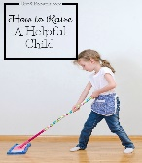  Service Hour | Draw a picture of someone | Make a phone call to a relative | Write a card or letter to someone to say Hello | Tidy you room | Match Tupperware lids and bottoms | Fold your clothes | Write a card or letter to someone to say thankyou | Teach someone else how to do something | Hoover a room in your house (ask a parent first) | Do the  washing up

