

**40 x 50cm**

**Print**

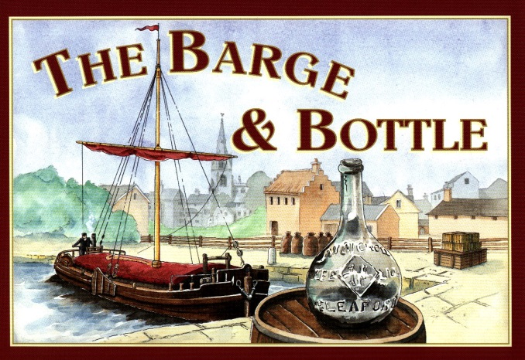

**£20 voucher**

**To use at and donated by**

**Talons Beauty**

**Bottle of wine**

**TBC**

**One month Free Membership**

**For and donated by New Image Gym**

**Meal for 2 up to the value of**

**£20 to use at**

**The Packhorse Inn, Sleaford**



**4 Wristbands**

**For and donated by Fantasy Island**

**Acer Aspire Laptop**

**Donated by Nationwide School Uniforms**

**Family Pass**

**For and donated by**

**Tattershall Farm Park**

**Church Lane Primary School Summer Raffle 2021**

**Prize List**

**£20 voucher**

**to use at and donated by**

**Little Hair Beautique**



**£25.00 Voucher**

**To use at and donated by**

**Bellissimo Boutique**

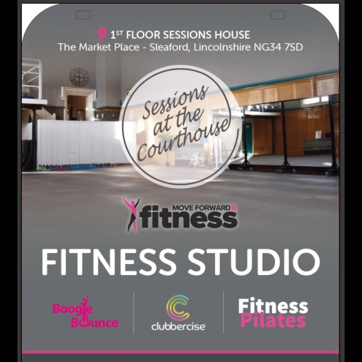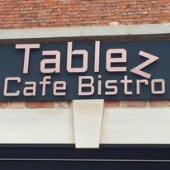

**2 x taster sessions**

**For**

**Move Forward Fitness**

**Voucher for Balloon**

**Display of 3 balloons**

**TBC**

**£10 Voucher to use towards**

**SA training or**

**SA clothing range**

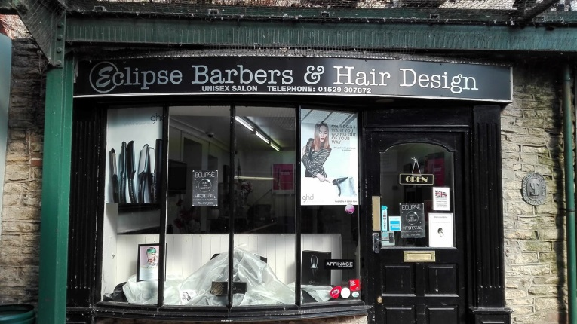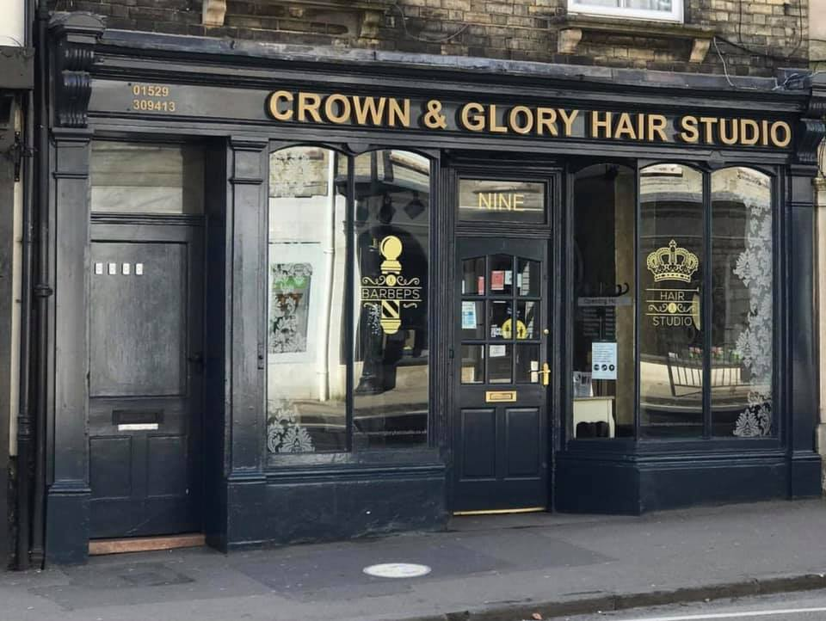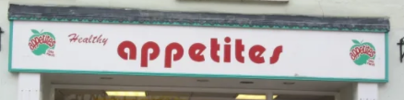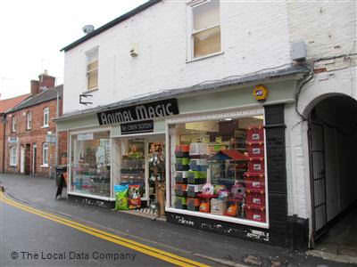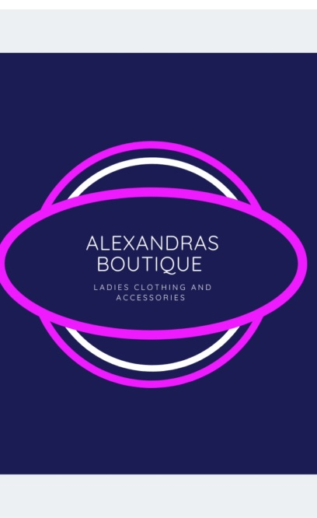

**A family ticket**

**For and donated by**

**Lincoln Castle**

**2 x £10 vouchers**

**to use at and donated by**

**Eclipse Barbers & Hair Design**

**TBC**

**L’OREAL Professional**

**SERIE EXPERT**

**Shampoo and Conditioner set**

**Kong Whoopz**

**Dog Toy**

**£20 gift voucher**

**To use at and donated by**

**Alexandras Boutique**