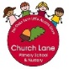Year N spring educational programme 2020-2021

This is a flexible educational programme- it will be adapted to suit the needs of the cohort and will be guided by the children’s goals, interests and gaps in learning.

Spring

Alongside our ‘in the moment’ planning we will provide the children with the following experiences to ignite learning, spark new interests and teach knowledge and skills.

The experiences and continuous provision enhancements provided will go hand-in-hand with their social and personal development.

Physical Development

Our indoor and outdoor environment will be set up to provide the children will all the skills to promote gross and fine motor skills.

This term we will continue to focus on supporting **gross motor skills**- core strength, stability, balance and spatial awareness. The children will have daily access to the field where games and equipment will be provided to encourgae gross motor skills. The children will access the field at the start of their session to wake up their minds and bodies.

Dough will be avialible very day to work on strengthning our finger muscles. The children will access the hall to take part in Cosmic Yoga and Go Noodle sessions.

Move with Zip Active will also be used to promote each child’s physical development.

The children will develop their fine motor skills through their play.

Communication and Language

Every child will take part in a language assessment (Wellcomm). This will help identify any gaps in language development and will support our planning to close the gaps. Parents will be informed throughout and also given some activity ideas to help at home too.

Alongside sharing stories based on child’s interests we will focus on a ‘story a week.’ These stories will introduce each child to **rich vocabulary** where the children will explore the meaning in a playful way. The language will foster their understanding of our culturally, socially, technologically and ecologically diverse world. The children will be encouraged to talk about the seasonal change through their experiences and the books we read.

For example The Gruffalo’s Child will introduce the children to words such as whiskers, shadow, moon. The books such as The Gingerbread Man, Superworm and Shark in the Park will encourage rhyme and rhythm and encourage the children to join in with repeated refrains.

This term will be re-introduced to some our favourite characters – The Gruffalo and Ferdie. We will re-cap what we can remember about them from the previous stories.

Nursery rhymes will also play a big part of our daily routine and the children will take part in **working memory games such as pairs.**

Key Texts to ignite and inspire learning

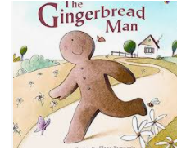 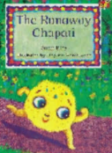 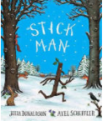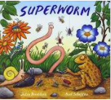 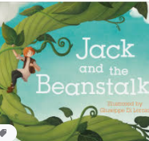 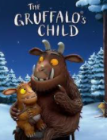 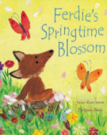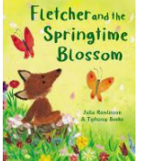

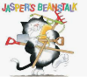

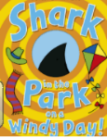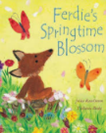

Personal, social and Emotional Development

The children will settle back into routine and continue to establish secure relationships with their key worker and other staff members. The children will become familiar with the indoor and outdoor environments and expectations. Staff will begin building new parent relationships using Tapestry and daily handovers. The children will begin to share their experiences from home e.g. Christmas holiday photos that have been uploaded to Tapestry

The children will be supported to use the toilet and independence skills will be promoted throughout the daily routines. Key workers will work with parents to establish individual needs and work together to create a support plan (if needed).

Children will be encouraged to prepare snack and help to serve. The children will be encouraged to wash up their own plates and bowls. Good table manners will be role-modelled as hot lunches are served.

Maths

Developing early Maths takes happens throughout the daily routines and equally as importantly through play. We will carefully look for opportunities where we will support the children to develop and deepen their understanding to 5.

We will use snack time to support our mathematical development. The children will be asked questions such as who has more/who has less. They will compare quantities and practice careful counting. The children will pour their own drinks which will encourage the use of language such as, ‘full’, ‘empty’, ‘half full’ etc.

Our number rhymes that we will explore are: Five Little Snowman, Five Little Speckled Frogs, One, Two, Three, Four, Five, Once I caught a fish alive and Five currant buns.

Literacy

Communication and Language are directly inter-linked with our Literacy programme.

In addition we will expose the children to Phase 1 Letters and Sounds Phonics. We will focus on Rhythm and Rhyme, Alliteration and voice sounds

Understanding of the World

We will read books such as The Gingerbread Man, The Runaway Chapatti, Superworm, Jack and the Beanstalk, Stickman, The Gruffalo’s Child, Ferdie’s Spring time blossom, Shark in the Park on a windy Day, Jasper’s Beanstalk to talk about winter and the beginning of spring, Chinese New Year, Pancake Day and Easter.

We hope to explore Sleaford by visiting the market, River Slea and Tesco to widen our experiences and help us develop our understanding of our world and immediate surroundings.

We will use the change in weather to explore the change in state e.g. water to ice. We will begin planting activities to talk about the growth and decay. We will bake Gingerbread Man linked to our story The Gingerbread Man.

Expressive Arts and Design

The children will learn new songs and rhymes throughout this term. The children will take part in a dragon dance to celebrate Chinese New Year. The children will be introduced to the famous Artist Jackson Pollock (Splat paintings). Easter crafts will also be explored with the hope of inviting parents in to make and create with us (dependent on Covid restrictions).