Curriculum goal  At the end of Reception our children will be able to: | Skills to teach to achieve goal  Pre-school Reception
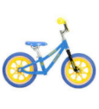  To ride a two wheeled bike | To practice riding a tricycle- pushing pedals | To practice riding a balance bike |  | To use a towel around the waist method to balance on a two wheeled bike | To ride successfully on a bike
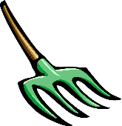  To be a confident gardener | Practice digging using real trowels  Plant seeds with support  Taking care of worms in the wormery | Taking care of individual plants and then the wider garden  Know names of common mini-beasts |  | Recognise a weed from a plant  Name common plants and trees  To look after mini-beasts found in garden e.g. put the worm back in freshly dug up soil. | Develop an understanding of compost heap  Developing a vegetable patch  Harvest crops independently- use food to cook with  Looking after whole garden
To construct with a purpose using real tools (wood work) | Practice using a mallet and golf tees  Introduce safety guidelines and wearing of small junior safety glasses. | Use Balsa wood and nails to introduce woodwork |  | Begin to introduce tools  8oz stubby ball pein hammer  Short stubby posidrive screwdrivers  Provide woods such as pine, cedar, fir  Exploration and building confidence | Begin to construct with a purpose in mind | Introduce saw and use with adult to cut wood to size |  | Children to create a whole school piece-team work
To have basic cooking skills e.g. make a sandwich, bake a cake  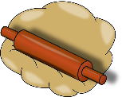  To foster an importance for managing oral hygiene  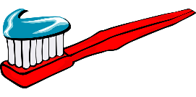 | To explore mixing, pouring, sieving and combining ingredients (sensory play)  Practice brushing teeth on a ‘dummy’ model.  Practice putting toothpaste on toothbrush | To practice using a range of real tools- peelers, safety knifes, graters, scales  To be shown how to brush teeth by an adult  Children to brush teeth as part of daily routine | To use tools to make a sandwich/prepare a fruit salad/bake a cake  with adult support-verbal instructions  Identify why it is important to brush teeth  Begin to understand which foods/drinks are good and bad for our teeth |  | To use tools to make a sandwich/prepare a fruit salad/bake a cake by following picture instructions  Be able to talk in more detail why it is important to look after our teeth  Share knowledge with others |  | To prepare and end of year party-making sandwiches/cakes independently  Children independently take ownership for brushing teeth at home and making right choices to what they eat and drink
Our creations with be used to support the community e.g Food Larder. We will fundraise by selling our cakes, produce grown in garden and crafts we create.

