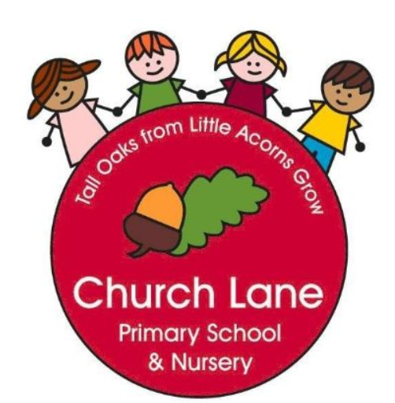 EYFS Curriculum: Maths
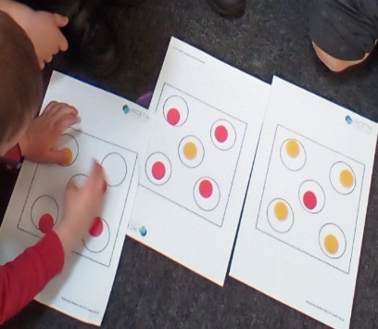
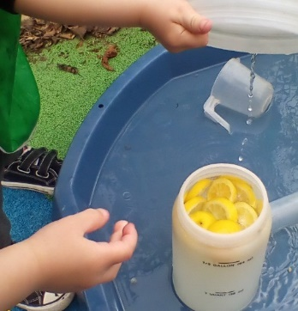
What does this look like across EYFS?
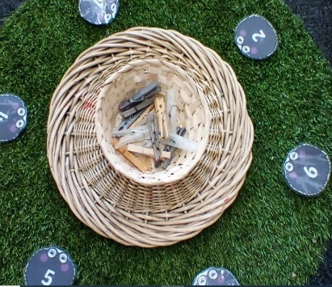
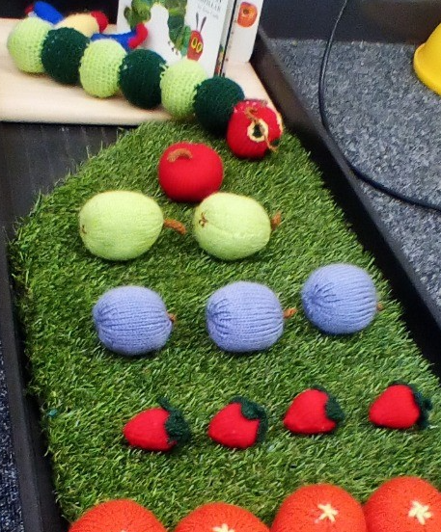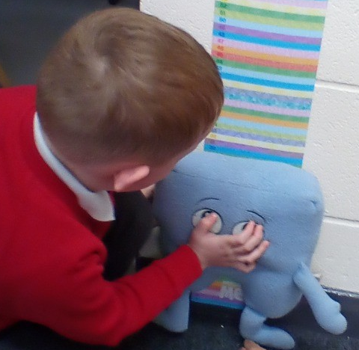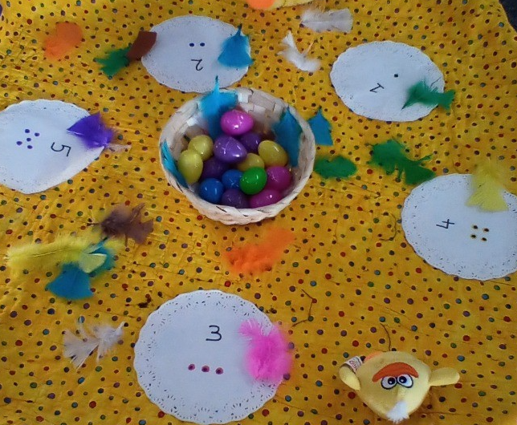
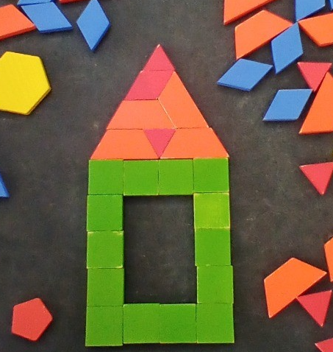
Our Educational Programme:
At Church Lane Primary School and Nursery we strongly believe in paving the way to ensure strong foundations are made throughout EYFS. We have a progressive curriculum which ensures all children have time to consolidate their mathematical learning and develop a deep understanding of numbers to 10. Across EYFS we follow White Rose Maths and Mastering Number programme with Number blocks playing a central part to developing mathematical understanding. Maths is seen everywhere inside and outside our provision, including snack time. We promote a ‘have a go’ attitude to Maths, supporting every child to feel confident to reason and explore all areas of Maths.
Below is our ambitious curriculum which shows progression across EYFS through the teaching of a variety skills and knowledge, including rich vocabulary. As our children move through the EYFS, the curriculum is designed to ensure all children develop the desired building blocks to ensure they have all the skills and knowledge needed to access National Curriculum. We will use the planned knowledge and skills as a guide (not rigid and not an exhaustive list) throughout the year and will adapt accordingly depending on cohort needs, interests and any gaps in learning.
Communication and Language is at the heart of the curriculum.

Below is our ambitious curriculum which shows progression across EYFS through the teaching of a variety skills and knowledge, including rich vocabulary. As our children move through the EYFS, the curriculum is designed to ensure all children develop the desired building blocks to ensure they have all the skills and knowledge needed to access National Curriculum. We will use the planned knowledge and skills as a guide (not rigid and not an exhaustive list) throughout the year and will adapt accordingly depending on cohort needs, interests and any gaps in learning.
Communication and Language is at the heart of the curriculum.

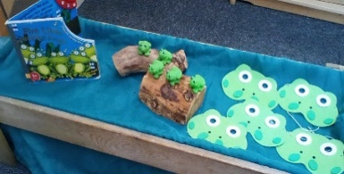
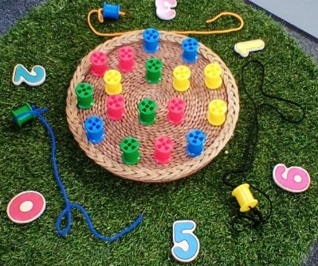
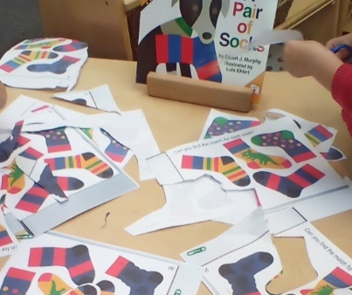
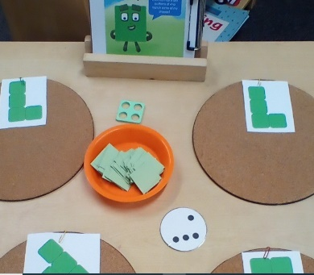
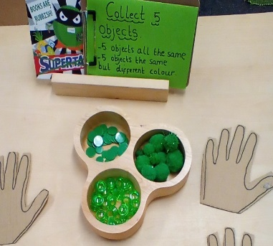
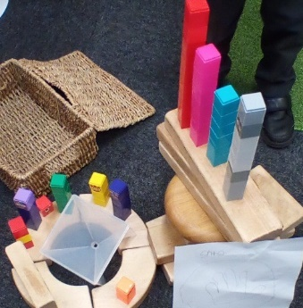
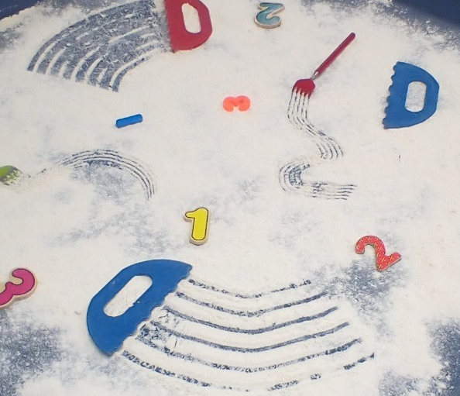
Progression document
National Curriculum links: Maths
 | Nursery | Number Rhymes | End of year goals  (School Readiness) | Reception | Key Vocabulary | Key books | Continuous Provision | End of term checkpoints
Autumn 1 | Number  Compare quantities- ‘more than’ and ‘fewer than’.  Show fingers up to 3 (flashy fingers)  Recite numbers names to 3.  Begin to recognise that counting is useful because it tells us how many we have.  Begin to understand that the last number reached when counting a small set of objects tells us how many in total (cardinal principle).  Counting 1:1 to 3  Identify when a collection has 3 and it remains as 3 even when it is re-arranged (Conservation)  Identify when a collection is composed of 1 or not 1.  Begin to subitise die patterns 1-3  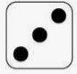  Measure, Shape and Spatial thinking  Begin to talk about and identify patterns around them e.g. stripes on clothes, designs on rugs and wallpaper etc. | Five Little Pumpkins  One Potato, Two Potato  One Two Buckle My Shoe  Three Blind Mice  Two Little Dickie Birds  Five Mince Pies |  | Number  Match and Sort  Compare amounts  Subitise 1, 2, 3.  Make and describe spatial patterns with 3 dots.  Represent quantities in different ways using fingers.  Match and sort objects.  Recognise that counting is useful because it tells us ‘how many.’  Recognise that the last number in the count tells us ‘how many altogether.’  Recognise that 2 is made of 1 and ‘another 1.’  Identify when a collection is composed of 3 objects.  Identify when a collection is composed of 3 or not 3.  Use positional language to describe patterns of 4.  Compare 2 sets of objects and say which is ‘more than’ or ‘fewer than.’  Measure, Shape and Spatial thinking  Compare size, Mass and Capacity  Make simple patterns | Compare  Numeral  Subitise  Match  Pairs  Sort  Odd one out  Large/small  Few/fewest  More/most  Small/large  Tall/thin  Pattern/repeating pattern  Count | The button box  Dear Zoo  Noah’s Ark  Which one doesn’t belong  A Squash and a Squeeze  The Enormous Turnip  Dear Zoo  Mr.Big  We’re Going on a Bear Hunt | Snap cards  Jigsaws  Number shapes  Blocks  Small shapes  Small/big trowels | - compare 2 sets of up to 3 objects by looking and/or matching, regardless of the colour, size or type of objects being compared?  - look at 2 sets of up to 3 similar objects and say which has more?  - say or demonstrate using practical equipment ‘1 more than’ a number to 3?  - join in with counting rhymes and activities?  - tag 1-to-1 for numbers to 3?  - Recognise a repeating pattern?  - show numbers to 5 (without counting) on their fingers, using both hands or by using the Fingers up?  - recognise and match numerals to quantities up to 3?  - say the number of up to 3 clearly defined objects in different contexts, without counting?
Autumn 2 | Number (same as above and below)  Begin to match different representations of quantities to 3 with fingers.  Counting 1:1 to 3  Recite number names to 3  Say the counting sequence in a variety of playful contexts, forwards and backwards e.g. hide and seek, rocket-launch count-downs (can be past 5)  Match numerals 1-3 to the right number of objects.  Identify when a collection is composed of 2 or not 2.  Identify when a collection has 3 and it remains as 3 even when it is re-arranged (Conservation)  Measure, Shape and Spatial thinking  Begin to discuss questions about shapes/shape puzzles/shape-sorters e.g. What is the same and what is different?  Begin to explore 2D shapes and informally talk about shape properties ‘sharp corner,’ ‘pointy’ or ‘curvy.’ | Five Little Pumpkins  One Potato, Two Potato  One Two Buckle My Shoe  Three Blind Mice  Two Little Dickie Birds  Five Mince Pies |  | Number  Representing 1-5  Collect five objects and show 5 using hand template.  Say and make numbers to 5.  Use a die frame to represent 5  Count 5 and 5 to make 10 altogether  Match different representations of quantities to 5 with fingers.  Represent quantities in more abstract way e.g. clapping/jumping  Recognise numerals to 5  Understand that when a set of objects is rearranged, the quantity stays the same.  Comparing 1-5  Recognise ‘more than’ or ‘fewer than’ by looking.  Recognise when there is an equal number.  Recognise when there is an equal number, too many or nor enough.  Build and match towers with an equal number of squares.  Composition of 1-5  Identify whole and part of a familiar object.  Identify parts of own body.  Recognise that some whole objects have parts that cannot be removed.  Know that 1 and 2 are parts of 3.  Explore how 1 and 2 are parts of 3.  Investigate ways to compose and de-compose 4 and 5.  Measure, Shape and Spatial thinking  Circles and Triangles  Positional language  Recognise that a triangle has 3 sides.  Recognise that a circle has 1 curved side.  Recognise shapes with 4 sides. | Represent  Compare  One more/One less  More than/fewer than  What do you notice?  Shape names  Curved  Straight  Positional language  Part  Whole  Altogether  Equal | Circle/Triangle  The Three Little Pigs  BBC Number Blocks 1,2,3  The Three Billy Goats Gruff  The Mr.Men books  Anno’s Counting Book  Five Little Peas rhyme  Days of the week song  Pete the Cat and his 4 groovy buttons  Square | Loose parts  Dough  Track games  Kandinsky Art  2D and 3D printing  jigsaws  Beanbags and numbered buckets  Rhyme table  Multi-links cubes  Visual timetable | - compare 2 sets of up to 5 objects by looking and/or matching, regardless of the colour, size or type of objects being compared?  - look at 2 sets of up to 5 similar objects and say which has more?  - say when 2 sets have an equal number of objects?  - make 2 sets that have an equal number of objects?  - say or demonstrate using practical equipment ‘1 more than’ a number to 5?  - say or demonstrate using practical equipment ‘1 less than’ a number to 5?  - join in with counting rhymes and activities?  - tag 1-to-1 for numbers to 5?  - count a set of up to 5 objects, and then say how many there are altogether, without re-counting?  - Apply counting skills in play?  - show numbers to 5 (without counting) on their fingers, using both hands or by using the Fingers up?  - show numbers to 5 (without counting) on their fingers, using both hands or by using the Fingers up?  - recognise and match numerals to quantities up to 5?  - split a set of up to 5 objects into 2 parts, recognising that the whole amount remains the same?  - say the number of up to 3 clearly defined objects in different contexts, without counting?
Spring 1 | Number (same as above plus below)  Recognise numerals to 3 and collect equal number (same) of objects  Identify when a collection has 3 and it remains as 3 even when it is re-arranged (Conservation)  Develop subitising skills to 3 (“fast eyes”)  Count 1:1 to 5  Recite number names past 5  Begin to record numbers in own way. E.g. how many balls they managed to throw through the hoop.  Identify when a collection is composed of 3 or not 3.  Fast recognition of up to 3 objects (irregular arrangement), without having to count them individually (subitising).  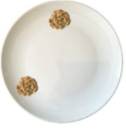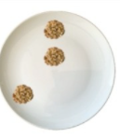  NB: When subitising irregular amounts to stretch say “There are 3 biscuits altogether. I can 2 and 1. How do you see it?”  Measure, Shape and Spatial thinking  Begin to make comparisons between objects relating to weight and capacity- heavy, light, full, empty. | Five Little Snowman  Five Speckled Frogs  One, Two, Three, Four, Five Once I caught a Fish alive  Five Currant buns |  | Number  Match different representations of quantities to 5 with amounts on fingers.  Recognise numerals to 5 and collect equal number of objects.  Represent quantities in more abstract way e.g. clapping/jumping  Understand that when a set of objects is rearranged, the quantity stays the same.  Develop conceptual subitising with linear and paired arrangements of up to 5.  Visualise and recreate arrangements of 3,4,5,dots.  Visualise and describe arrangements on a die and link to 1:1 counting actions.  Use die patterns to play track games.  Recognise and order numerals 1-5  Recognise that each number is 1 more.  Notice when we have 1 more and when we don’t have 1 more.  Represent staircase patterns in different ways.  Recognise that 5 is made of 4 and 1.  Recognise that 5 is made of 3 and 2  Find ways to partition a set of 5.  Use their knowledge of 5 to find a hidden number  Recognise that there are 5 dots on a die pattern  Represent 6 on a double dice frame and understand that 6 is 5 and 1 more.  Recognise that 7 is 5 and 2 more.  Measure, Shape and Spatial thinking  Compare Mass (2)  Compare Capacity (2) | Compare  Subitise  Heavy/Light  Heavier/lighter  Full/empty  Half full/nearly full  Narrow/ wide  Equal  Numerals  Spatial language e.g. diagonal, straight, top, bottom, next to  Die/Dice  More | Anno’s Counting Book  Number Blocks  Ten in the Bed  Who Sank the Boat | Dot Plates  Numicon  Balance scales  Buckets with strong elastic bands  Narrow/wide containers  Dice  Track games | - say when 2 sets have an equal number of objects?  - make 2 sets that have an equal number of objects?  - say or demonstrate using practical equipment ‘1 more than’ a number to 5?  - say or demonstrate using practical equipment ‘1 less than’ a number to 5?  - join in with counting rhymes and activities?  - tag 1-to-1 for numbers to 5?  - count a set of up to 5 objects, and then say how many there are altogether, without re-counting?  - Apply counting skills in play?  - show numbers to 5 (without counting) on their fingers, using both hands or by using the Fingers up?  - recognise and match numerals to quantities up to 5?
Spring 2 | Number (same as above plus below)  Recognise numerals to 4 and collect equal number (same) of objects  Identify when a collection has 4 and it remains as 4 even when it is re-arranged (Conservation)  Develop subitising skills to 4 (“fast eyes”)  Begin to record numbers in own way. E.g. how many balls they managed to throw through the hoop.  Identify when a collection is composed of 4 or not 4  Count 1:1 to 5  Show fingers up to 4 (flashy fingers)  Recite number names past 5  Measure, Shape and Spatial thinking  Talk about and explore 2D and 3D shapes informally e.g. in block area, outside e.g. ‘sides’, ‘corners’; ‘straight’, ‘flat’, ‘round’. | Five Speckled Frogs  One, Two, Three, Four, Five Once I caught a Fish alive  Five Currant buns |  | Number  Explore ‘5 and a bit’ ways to make numbers between 6-10  Investigate 1 more and 1 less pattern  Begin to order numbers between 1-10  Subitise arrangements of 6 not 6  Represent 8 as ‘5 and 3 more.’  Reason about which numbers are ‘more than’ others.  Notice when numbers are increased or increased and why.  Describe parts of a whole set using conceptual subitising.  Investigate ways of making 7 with two ways.  Notice when towers are made of 7 or NOT 7.  Work out missing parts of 7.  See that 7 can be composed in different ways.  Use fingers to show 2 and 4 as doubles.  See when a pattern is and when it is NOT a double.  Make doubles patterns.  Sort objects according to attributes they notice.  Describe attributes of the Numberblocks.  Sort the Numberblocks using the criteria ‘odd blocks’ or ‘even tops’.  Investigate patterns of doubles.  Measure, Shape and Spatial thinking  3D shapes  Spatial Awareness  Patterns | What do you notice?  Total  Compare  Number Bonds  3D shape names  Different  Same  Repeating pattern  Same  Different  Odd  Even  patterns | Ten Black Dots  Pattern Bugs  Pattern Fish  Engines Engines  Farmer Pete!- You Tube  Number Blocks: Blast Off  Mouse Shapes | Ten Green Bottles  3D shapes  Pattern Bugs  Pattern Fish | - say when 2 sets have an equal number of objects?  - make 2 sets that have an equal number of objects?  - say or demonstrate using practical equipment ‘1 more than’ a number to 9?  - say or demonstrate using practical equipment ‘1 less than’ a number to 9?  - join in with counting rhymes and activities?  - tag 1-to-1 for numbers to 10?  - count a set of up to 10 objects, and then say how many there are altogether, without re-counting?  - Apply counting skills in play?  - recognise the difference between an odd and an even number?  - show numbers up to 10 (without counting) on their fingers, using both hands or by using the Fingers up?  - recognise and match numerals to quantities up to 10?
Summer 1 | Compare quantities- ‘more than’ and ‘fewer than’.  Recognise numerals to 5 and collect equal number (same) of objects  Identify when a collection has 5 and it remains as 5 even when it is re-arranged (Conservation)  Develop subitising skills to 3 (“fast eyes”) using die patterns and irregular arrangements.  Begin to record numbers in own way. E.g. how many balls they managed to throw through the hoop.  Show fingers up to 5 (flashy fingers)  Recognise numerals to 5 and collect equal number (same) of objects  Recite number names past 5  Count 1:1 to 5 (beyond if ready)  Measure, Shape and Spatial thinking  Use spatial language in play, including ‘in’, ‘on’ ‘under’, ‘under’, ‘down’, ‘besides’ and ‘between.’ | Five Little Ducks  Five Little Monkeys  Five Fat Sausages  Five Little Men in a Flying Saucer  Here is the Beehive! |  | Number  Practise strategies for counting larger sets  Represent own collections of larger amounts  Practice counting on from a given number  Subitise to 6  Subitise double amounts shown on 10 frames  Use fingers to make double patterns  Use fingers to represent numbers within five  Use die frames to represent numbers within 5  Explore ways to make 5 using 10-frames  Represent numbers within 10 using 10-frames and double dice frames  Match 10-frames with numerals and fingers  Explore ways to make 10  Understand when to subitise and when to count  Say the different ways that 10 can be made  Identify missing numbers in the counting sequence to 5 and then 10  Order numbers 1-10  Use language to describe positions on a number track  Measure, Shape and Spatial thinking  Spatial Reasoning  Match, rotate, manipulate | Number blocks: Series 3  What’s the same?  What’s different?  Rotate  Subitise  More than/less than  10-frames  Double | Which one doesn’t belong?  One Moose, 20 Mice  One Ted Falls Out of bed  Quack and Count  Mr. Gumpy’s Outing  Grandpa’s quilt  Number blocks: Double Trouble  The Doorbell rang  Pete the Cat and the Missing Cupcakes  The Doorbell Rang  Number blocks: Odd and Even  How Many Legs? | Race to 20 tracks  Bingo  One hundred squares  Shape puzzles  Track games  First, Then, Now stories  Race to Zero games  Creating Tangrams | - say or demonstrate using practical equipment ‘1 more than’ a number to 9?  - say or demonstrate using practical equipment ‘1 less than’ a number to 9?  - begin to develop a ‘mental number line’? Do they know, for example, that 8 is a lot more than 2, but 4 is only a little bit more than 2?  - join in with counting rhymes and activities, consistently saying the number names in the correct order?  - tag 1-to-1 for numbers to 10?  - count a set of up to 10 objects, and then say how many there are altogether, without re-counting?  - Apply counting skills in play?  - show doubles amounts on their fingers? Can they show and explain a number that is NOT a double?  - use representations (e.g. interlocking cubes, 10-frames, Rekenrek, etc.) to make even and odd numbers?  - recognise the difference between an odd and an even number?  - tell you the sum of some doubles within 10?  - show numbers up to 10 (without counting) on their fingers, using both hands or by using the Fingers up?  - recognise and match numerals to quantities up to 10?  - say the number of up to 5 clearly defined objects in different contexts, without counting?
Summer 2 | Compare quantities- ‘more than’ and ‘fewer than’.  Count 1:1 to 5 (beyond if ready)  Recite number names past 5  Recognise numerals to 5 and collect equal number (same) of objects  Identify when a collection has 5 and it remains as 5 even when it is re-arranged (Conservation)  Develop subitising skills to 3 (“fast eyes”) using die patterns and irregular arrangements.  Begin to record numbers in own way. E.g. how many balls they managed to throw through the hoop.  Show fingers up to 5 (flashy fingers)  Recognise numerals to 5 and collect equal number (same) of objects  Measure, Shape and Spatial thinking  Extend and create an ABAB pattern  Notice and correct a mistake in the ABAB pattern | Five Little Ducks  Five Little Monkeys  Five Fat Sausages  Five Little Men in a Flying Saucer  Here is the Beehive! | - To have fast recognition of up to 3 objects (subitise)  - To recite number names past 5  - To know that the last number reached when counting tells us how many there are in total  - To link numerals and amounts up to 5 objects  - To compare quantities using language, ‘more than’ and ‘fewer than’  - Talk about 2D and 3D shapes  - Can extend and create an ABABAB pattern | Review and assess  Subitise numbers to 5 and make equivalent amounts with Rekenreks  Count out and arrange 6 or 8 objects  Count 20 objects  Practise saying the ‘tricky’ teen numbers  Practise counting to 100  Make and describe doubles on fingers  Sort numbers to 10 according to whether each number is a double / is not a double.  Use fingers to make matching doubles amounts  Make and describe doubles patterns on a Rekenrek.  Find ways to partition (split) a set of 5  Use fingers to make and describe doubles facts  Explore the commutativity of addition facts  Explore and represent the composition of 5 on Rekenrek  Work out missing numbers to 10  Orientate a Rekenrek correctly and push a number of beads with one finger  Use ‘one finger, one push' to subitise and explore ‘1 more' patterns of beads on the Rekenrek. | Revisit previous vocabulary | Revisit previous stories and rhymes | Rekenrek | Early Learning Goal:  Compare quantities up to 10 in different contexts, recognising when one quantity is greater than, less than or the same as the other  Verbally count beyond 20, recognising the pattern of the counting system  Explore and represent patterns within numbers up to 10, including evens and odds, double facts and how quantities can be distributed equally.  Automatically recall (without reference to rhymes, counting or other aids) number bonds up to 5 (including subtraction facts) and some number bonds to 10 (including doubles facts)  Have a deep understanding of number to 10, including the composition of each number  Subitise (recognise quantities without counting) up to 5

