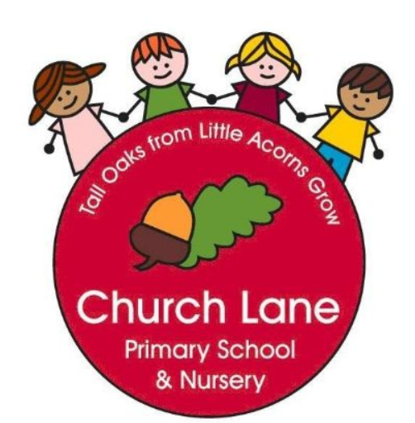 EYFS Curriculum: Communication and Language
Our Educational Programme:
At Church Lane Primary School and Nursery we believe that Communication and Language underpins all areas of learning. Our daily interactions, environments and planned curriculum ensure all children are exposed to rich language opportunities. Over the seven areas of learning we carefully plan stories, vocabulary and real-life experiences that are going to stretch all children, including children who have English as an additional language. We ensure new vocabulary is embedded and re-visited across EYFS.
As children start our setting we immediately identify any children who may need extra support with developing their communication and language skills. We work closely with parents and our SENDCo to ensure support is put in place as quickly as possible. At Church Lane Primary School, we use WellComm to identify any gaps and then use this programme to deliver either group or 1:1 interventions. We also use basic Makaton to support children with communication and language difficulties.
We do not split Communication and Language into terms as it is tailored to each individual child, therefore starting points are very different. However, we do ensure certain skills are taught throughout the year. We also have a bank of our favourite rhymes, poems (Poetry Basket) and stories that we learn across EYFS until children can confidently recite them back. We will involve our families to support us with this ambition by providing links to the poems, rhymes and books. We explore the vocabulary within the rhymes, poems and story books, starting with an object or visual aid. In addition to the story/rhyme vocabulary we teach abstract concepts as suggested by Anne Locke. We will explore this vocabulary across the EYFS using a multi-sensory approach.

Communication and Language is at the heart of our curriculum

 | Across the year Nursery will be learning to: | Across the year Reception will be learning to:
 | Enjoy listening to longer stories and can remember much of what happens.  Can find it difficult to pay attention to more than one thing at a time.  Use a wider range of vocabulary.  Understands questions or instructions that has to parts.  Understand ‘why’ questions.  Sing a large repertoire of songs,  Use longer sentences of four to six words  Express a point of view with words and actions.  Can start a conversation with an adult or a friend.  Use talk to organise themselves and their play. | Understand how to listen carefully and why listening is important.  Learn and use new vocabulary.  Use new vocabulary through the day.  Ask questions to find out more.  Articulate their ideas and thoughts in well-formed sentences.  Connect one idea or action to another using a range of connectives.  Describe events in some detail.  Use talk to organise thinking and activities and explain how things work and why.  Develop social phrases.  Engage in story times.  Listen and talk about stories to build understanding.  Retell the story using some exact repetition and some in their own words.  Listen and learn rhymes and songs, paying attention to how they sound.  Engage in non-fiction books and talk about new vocabulary.

Our story time favourites: we will re-read and rehearse until children can confidently recite them back.
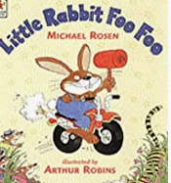
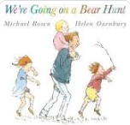
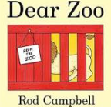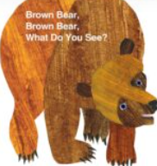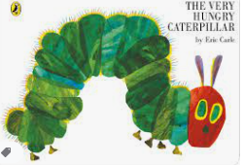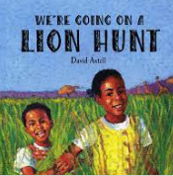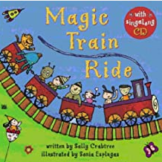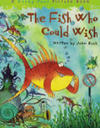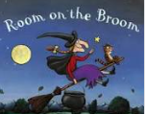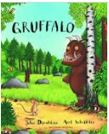

Our favourite poems: we will rehearse until children can confidently recite them back and perform to our Church Lane community.
Falling apples Mrs Blue Bird
Shoes A Little Seed
Leaves are falling Sliced Bread
I can build a snowman I have a Little Frog
Lets put on our mitten
Across EYFS we use Anne Locke’s list of abstract concepts. We begin teaching at Level 1 and then move through the concepts. We will teach the planned vocabulary in a multi-sensory way across the whole curriculum.
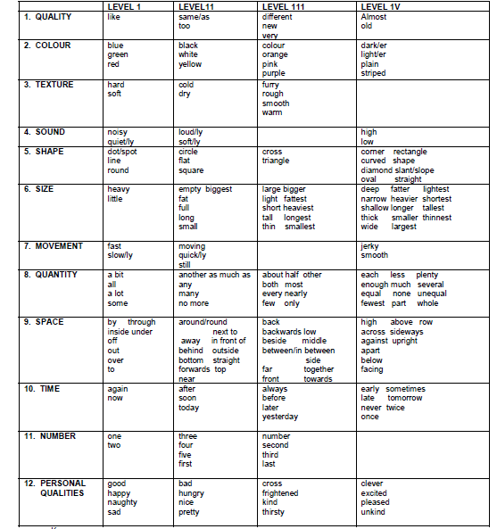

From “Putting Words together”, part of ‘Living Language’ Ann Locke 1995

