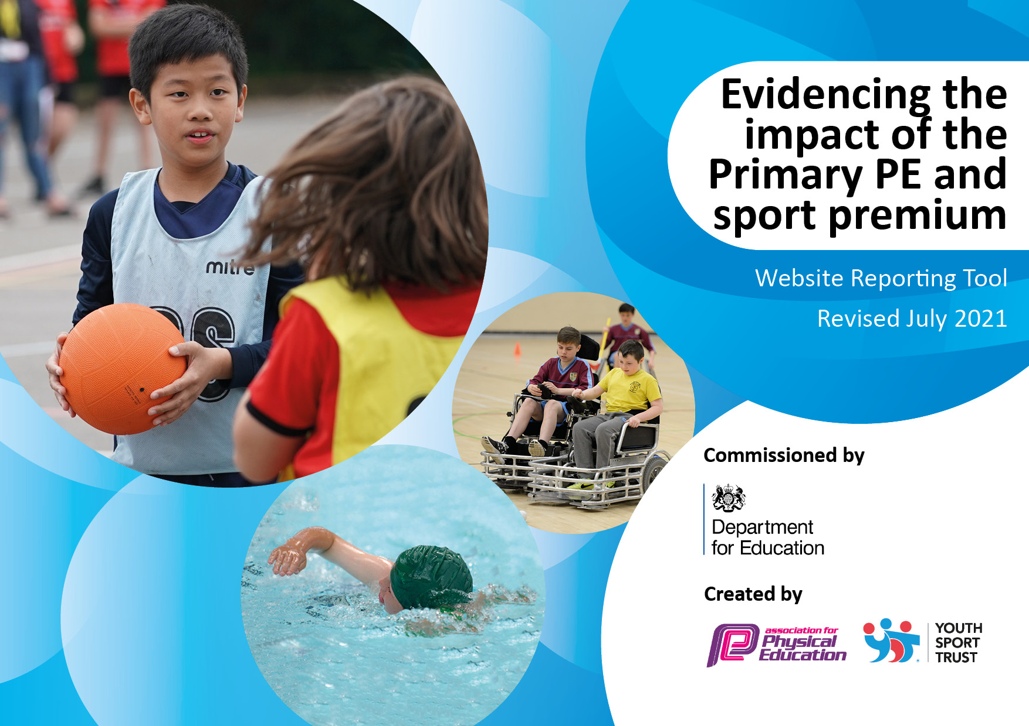
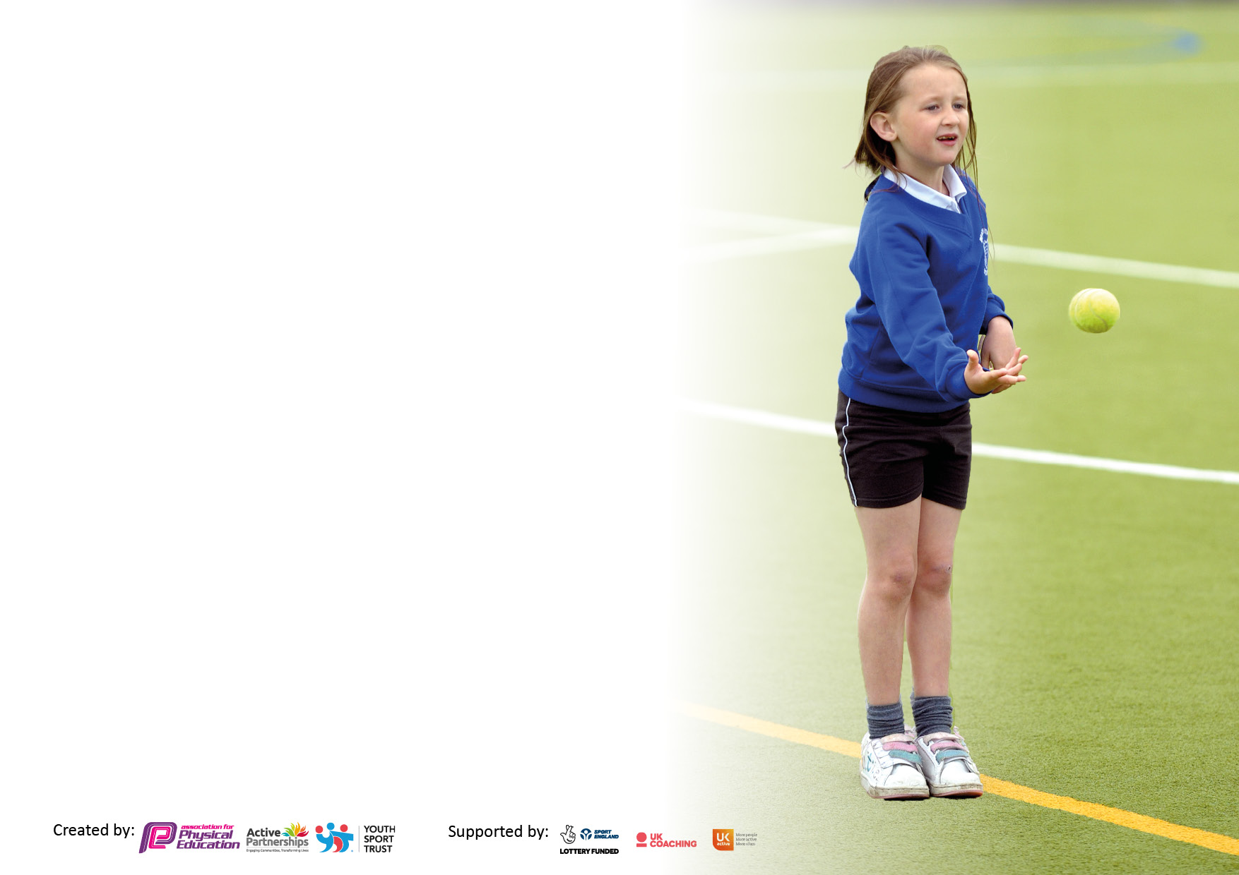

It is important that your grant is used effectively and based on school need. The Education Inspection Framework makes clear there will be a focus on ‘whether leaders and those responsible for governors all understand their respective roles and perform these in a way that enhances the effectiveness of the school’.

Under the Quality of Education Ofsted inspectors consider:
Intent - Curriculum design, coverage and appropriateness
Implementation - Curriculum delivery, Teaching (pedagogy) and Assessment
Impact - Attainment and progress

To assist schools with common transferable language this template has been developed to utilise the same three headings which should make your plans easily transferable between working documents.

Schools must use the funding to make additional and sustainable improvements to the quality of Physical Education, School Sport and Physical Activity (PESSPA) they offer. This means that you should use the Primary PE and sport premium to:

- Develop or add to the PESSPA activities that your school already offer
- Build capacity and capability within the school to ensure that improvements made now will benefit pupils joining the school in future years
- The Primary PE and sport premium should not be used to fund capital spend projects; the school’s budget should fund these.

Pleasevisitgov.ukfortherevisedDfEguidanceincludingthe5keyindicatorsacrosswhichschoolsshoulddemonstrate animprovement.Thisdocumentwillhelpyoutoreviewyourprovisionandtoreportyourspend.DfEencouragesschools to use this template as an effective way of meeting the reporting requirements of the Primary PE and sport premium.

We recommend you start by reflecting on the impact of current provision and reviewing the previous spend.

Schools are required to publish details of how they spend this funding, including any under-spend from 2019/2020, as well as on the impact it has on pupils’ PE and sport participation and attainment. All funding must be spent by 31st July 2022.

We recommend regularly updating the table and publishing it on your website throughout the year. This evidences your ongoing self-evaluation of how you are using the funding to secure maximum, sustainable impact. Final copy must be posted on your website by the end of the academic year and no later than the 31st July 2021. To see an example of how to complete the table please click HERE.
Created by: Supported by:

Details with regard to funding
Please complete the table below.

Total amount allocated for 2021/22 | £17, 780 (however over spend of £1080 previous year)
Total amount of funding for 2021/22. To be spent and reported on by 31st July 2022. | £ 16, 700
Swimming Data
Please report on your Swimming Data below.

Meeting national curriculum requirements for swimming and water safety.  N.B. Complete this section to your best ability. For example you might have practised safe self-rescue techniques on dry land which you can then transfer to the pool when school swimming restarts.  Due to exceptional circumstances priority should be given to ensuring that pupils can perform safe self rescue even if they do not fully meet the first two requirements of the NC programme of study | 87%
What percentage of your current Year 6 cohort swim competently, confidently and proficiently over a distance of at least 25 metres?  N.B. Even though your pupils may swim in another year please report on their attainment on leaving primary school at the end of the summer term 2021.  Please see note above | 75%
What percentage of your current Year 6 cohort use a range of strokes effectively [for example, front crawl, backstroke and breaststroke]?  Please see note above | 75%
What percentage of your current Year 6 cohort perform safe self-rescue in different water-based situations? | 75%
Schools can choose to use the Primary PE and sport premium to provide additional provision for swimming but this must be for activity over and above the national curriculum requirements. Have you used it in this way? | No

Action Plan and Budget Tracking
Capture your intended annual spend against the 5 key indicators. Clarify the success criteria and evidence of impact that you intend to measure to evaluate for pupils today and for the future.

Academic Year: 2022/22 | Total fund allocated: 16,700 | Date Updated: July 2022
Key indicator 1: The engagement of all pupils in regular physical activity – Chief Medical Officers guidelines recommend that primary school pupils undertake at least 30 minutes of physical activity a day in school |  |  |  | Percentage of total allocation:
 |  |  |  | %
Intent | Implementation |  | Impact
Your school focus should be clear what you want the pupils to know and be able to do and about  what they need to learn and to  consolidate through practice: | Make sure your actions to achieve are linked to your intentions: | Funding allocated: | Evidence of impact: what do pupils now know and what can they now do? What has changed?: | Sustainability and suggested next steps:
To continue to work toward more children, more active, more of the time.  This will impact on the children’s academic achievements, mental wellbeing, self-esteem and overall fitness. | To continue to do fitness profiling to know where to target children/classes where focus is needed.  Sign post children to further opportunities in the local community  Track children’s participation in school sport and physical activities  A member of staff to attend forums and meetings and work closely with Carres Grammar. | £ | Children will be active for 30 minutes each day.  Track participation  A variety of clubs after school  Attend PE forums and conference with Carres outreach.  Each class to partake in Intra School Competition | Continue to enhance our after school offer  Church Lane Sports scholarship providing activity to disadvantaged free of charge.
Key indicator 2: The profile of PESSPA being raised across the school as a tool for whole school improvement |  |  |  | Percentage of total allocation:
 |  |  |  | %
Intent | Implementation |  | Impact
Your school focus should be clear what you want the pupils to know and be able to do and about  what they need to learn and to  consolidate through practice: | Make sure your actions to achieve are linked to your intentions: | Funding allocated: | Evidence of impact: what do pupils now know and what can they now do? What has changed?: | Sustainability and suggested next steps:
Children will feel a sense of pride in representing our school within the local community. Their engagement in school life will be more positive as a result of their participation in sport/extra-curricular activities.  Attendance at school will remain positive as a result. | After school clubs.  Use the participation tracker and fitness testing to identify what area’s need improving on as a school and implement them into lessons.  Termly level 1 house competitions to be done in all classes.  The school website and facebook feed will be used to communicate School Sport activities | £ | Through social media, parents are updated with all things sport and PE through photos and tweets.  This will see which children we can improve activity with, e.g girls football with children that attend out of hours child care that would not otherwise be able to attend. | Start our academy of Arts and Scholarship programme
To revise curriculum overview of subject in line with school aims and ensuring progression and coverage of the PE curriculum is continuing to happen.  To review subject policy to be in line with school vision and intent. | Revise current progression for our school and monitor to ensure this is taking place. Check against new government outlines for PE and good practice. | £500 | Continued to build confidence in teachers PE ability by SC providing help with dance and gymnastics.  Introduced new sports such as baseball and pop lacrosse. | Curriculum is in continuous development. Feedback to continue
Active lunchtimes to continue | To look at house captains becoming play leaders and working with ASCO.  Lunchtime assistants to act as play organisers where appropriate | £8000 | New equipment to be sourced | Continue to develop this by adding more active equipment such as den building
To use PE to support emotional needs of children to assist with mental health and wellbeing | To use school values and School Games Values to make cross curricular links with being active in health and wellbeing. In addition to make links between values in sport and with other academic subjects.  To continue to develop ELSA/Pastoral role in school with active sessions and including sensory circuits | £1244.14 | Targeted children to attend events which are appropriate to improve self esteem and confidence. Focus on mental health benefits of exercise.  To begin sensory circuits to help regulate children’s behaviour and equipment will need to be purchased. | Continue with this. Impact on vulnerable clear.

Key indicator 3: Increased confidence, knowledge and skills of all staff in teaching PE and sport |  |  |  | Percentage of total allocation:
 |  |  |  | %
Intent | Implementation |  | Impact
Your school focus should be clear | Make sure your actions to | Funding | Evidence of impact: what do | Sustainability and suggested
what you want the pupils to know | achieve are linked to your | allocated: | pupils now know and what | next steps:
and be able to do and about | intentions: |  | can they now do? What has
what they need to learn and to |  |  | changed?:
consolidate through practice:
 |  | £ |  | School to buy in a dance specialist to support with CPD
Key indicator 4: Broader experience of a range of sports and activities offered to all pupils |  |  |  | Percentage of total allocation:
Intent | Implementation |  | Impact
Your school focus should be clear | Make sure your actions to | Funding | Evidence of impact: what do | Sustainability and suggested
what you want the pupils to know | achieve are linked to your | allocated: | pupils now know and what | next steps:
and be able to do and about | intentions: |  | can they now do? What has
what they need to learn and to |  |  | changed?:
consolidate through practice:
School will use the funding to increase the number of opportunities available to our children both within and beyond the school day  Children will have positive, memorable experiences that increase their understanding of the range of sports there are  Broaden the opportunities within school for children to be physically active and engaged in sports  Improve confidence of children through delivery of sport.  New sports and small sided games introduced.  To give a wider range of sporting opportunities and enhance our dance and gymnastic offer. | Outreach will deliver sporting sessions with their expert knowledge and continue with Winter and Summer games (lead by children)  Continue to target and signpost specific children to activities that fit their needs.  To continue to deliver clubs and to teach classes new games. | £7572 | Dance Lobo opportunity ongoing with links to clubs  Continue to use fitness testing and participation tracker to identify those for the right events and activities.  Children experience new skills and consider how to transfer some of their existing skills into new sports  Children have increased confidence and are now able to take that confidence into the classroom and other situations outside of school. | Continue to develop this offer

Key indicator 5: Increased participation in competitive sport |  |  |  | Percentage of total allocation:
 |  |  |  | %
Intent | Implementation |  | Impact
Your school focus should be clear | Make sure your actions to | Funding | Evidence of impact: what do | Sustainability and suggested
what you want the pupils to know | achieve are linked to your | allocated: | pupils now know and what | next steps:
and be able to do and about | intentions: |  | can they now do? What has
what they need to learn and to |  |  | changed?:
consolidate through practice:
Children to experience competitions and festivals with/against other local schools | School to be a key part of the School Sport Partnership programme  Continue to target and signpost specific children to activities that fit their needs  To continue to get children to deliver clubs and to teach their classes new sports.  Offer to host more events  Use of staff to transport to events and buses  Additional hours to be paid to TA staff in order to cover or attend sporting | £1500 | Children can articulate the link between our school values and their presence in sport.  Children are exposed to new activities and environments | This to continue in the short term.

Signed off by
Head Teacher: | Mr C Clay
Date: | July 2022
Subject Leader: | Emily Smith
Date: | July 2022
Governor: | Barbara Jones
Date: | April 2022

