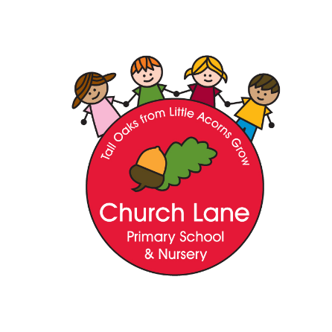

Church Lane Primary School and Nursery

Art and Design Policy

“Every child is an artist. The problem is how to remain an artist once we grow up” Pablo Picasso

“Creativity is contagious pass it on” Albert Einstein

Intent

At Church Lane, Art and Design is an important part of developing children’s ability to be creative, express their ideas and understanding and to work individually and collaboratively with others. The Art and design curriculum provides children with opportunities to develop their skills in the formal elements, including: line, colour, shape, texture and sculpture. Children will then apply these formal elements to the Art in Industry unit and the Art Movements unit of work.

Our Art and Design curriculum allows children to experience a variety of Arts past and present and allows them opportunity to explore, experiment and create.

We will ensure that our intention is met through:

- Using experiences, ideas and other subjects across the curriculum as inspiration for artwork
- We will develop and share ideas using, colour, line, shape, texture and sculpture.
- We will explore a variety of techniques
- We will learn about a range of artists and designers.
- We will use our local community as inspiration for our work
- We will have a clear progression through the years and key stages including EYFS.

Art and Design Curriculum Key stages 1 & 2

Key stage 1
As children progress through Key Stage 1 they will use their procedural knowledge to explore and develop their ideas through colour, line, shape, texture, and sculpture.
In Key Stage 1 the children will be taught:

- To use drawing, painting and sculpture to develop and share ideas, experiences and imagination.
- To develop a wide range of art and design techniques in using colour, texture, line, shape and sculpture.
- Learn about the work of a range of artists, craft makers and designers and make links to their own work.
- Begin to understand how art links to life outside of school.
- To use sketchbooks to record ideas/design.

Key stage 2

Children’s creative development builds on the experiences provided by Key Stage 1. Knowledge and skills are extended and developed.

In Key Stage 2 the children will be taught:

- To improve their mastery of the formal elements: colour, line, shape, texture, and sculpture.
- Develop their knowledge of Artists through looking at Art movements.
- Develop their understanding of how art links to life after school.
- To use sketchbooks to record ideas/designs.

Implementation:

- Lessons that plan for progression and depth
- Time to explore and experiment with knowledge and skills taught.
- Challenge questions to support children to apply their learning.
- Trips and visits to enhance the learning experience with close links to the National Centre for Craft and Design
- Displays will celebrate pupils’ artwork.

Impact

Our Art Curriculum is focused on procedural knowledge and progression of knowledge. We measure the impact through:

- Reflecting on standards achieved against the learning questions.
- Pupil discussions about their learning: thoughts, ideas, and evaluations of work

Art and Design Curriculum Early Years Foundation Stage

The Early Years Foundation Stage curriculum is based on seven areas of learning aiming to promote all aspects of a child’s development. Art and Design comes under the areas of learning:
Expressive Art and Design: Exploring and using media and materials.
Expressive Design: Being Imaginative

The EYFS curriculum starts from birth and children progress though each stage of development aiming to achieve the Early Learning Goals by the end of their Reception year. The assessment for the EYFS is formative. The Early Learning Goals relating to Art and Design are:

Exploring and using media and materials
Children sing songs, make music and dance and experiment with ways of changing them. They safely use and explore a variety of materials, tools and techniques, experimenting with colour, design, texture, form and function.

Being Imaginative
Children use what they have learnt about media and materials in original ways, thinking about uses and purposes. They represent their own ideas, thoughts and feelings through design and technology, art music, dance, role play and stories.

Assessment, Recording and Reporting

In Art and Design every child is an artist, and art is in the eye of the artist and viewer. What some people perceive as art others may disagree with and vice versa. Children will be assessed on the final pieces of Art when looking at art movements to gauge whether they have understood the movement. Throughout other areas of the curriculum afl will be used to gauge children’s knowledge. Assessments will take place over the course of the year where children will be marked against the lesson statements to understand their attainment level in art and design.

Policy written: September 2023
Written by: Charlotte Massingham
Review Date: September 2025

