CHURCH LANE PRIMARY SCHOOL AND NURSERY
BINGO NIGHT

JOIN US ON 22ND APRIL 2022

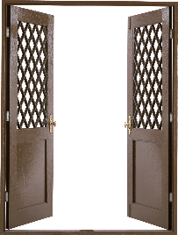OPEN 17:45
This Photo by Unknown Author is licensed under CC BY-NC
DOWN 18:30

TICKETS ON SALE FROM THE SCHOOL OFFICE

PLEASE NOTE NO TICKET NO ENTRY

