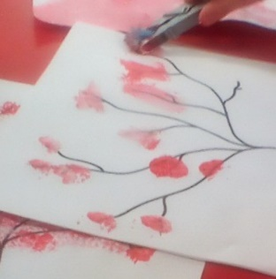
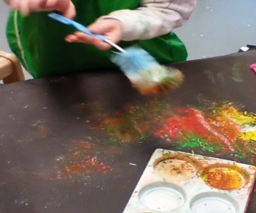
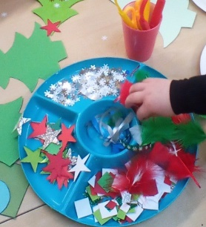
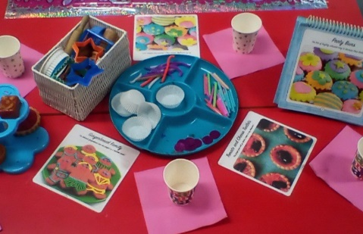
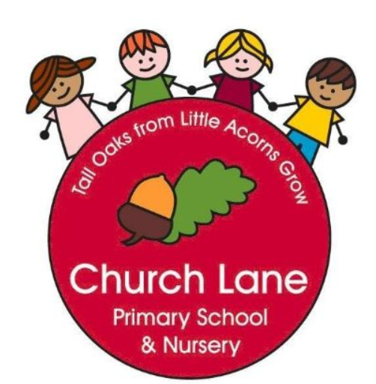 EYFS Curriculum: Expressive Arts and Design
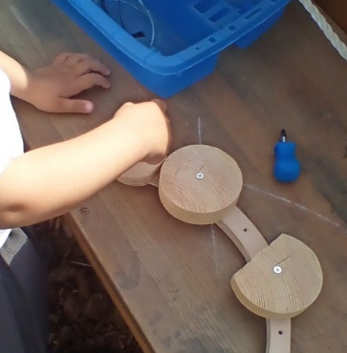
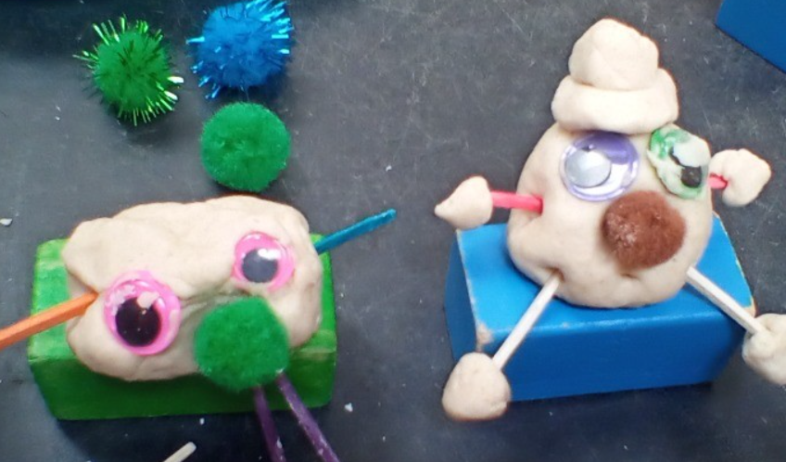
Our Educational Programme:
At Church Lane Primary School and Nursery we will support the development of children’s artistic and cultural through providing a variety of opportunities to support imagination and creativity. Throughout the EYFS our children will have opportunities to watch live performances. Our children will watch and listen to live music, theatre productions and our Reception children will go to a local theatre and watch a Pantomime. Our children will be encouraged to express themselves through different arts and will be encouraged to take part in dance, music and drama; our overall aim in to inspire children to be artists, designers, musicians, actors and dancers!
Both EYFS rooms are well equipped to spark imagination and creativity through the wealth of opened ended materials. Children will be inspired to choose freely and create their own masterpieces, using the skills and knowledge taught across the years.
Below is our ambitious curriculum which shows progression across EYFS through the teaching of a variety skills and knowledge, including rich vocabulary. As our children move through the EYFS, the curriculum is designed to ensure all children develop the desired building blocks to ensure they have all the skills and knowledge needed to access National Curriculum. We will use the planned knowledge and skills as a guide (not rigid and not an exhaustive list) throughout the year and will adapt accordingly depending on cohort needs, interests and any gaps in learning.
Communication and Language is at the heart of the curriculum.

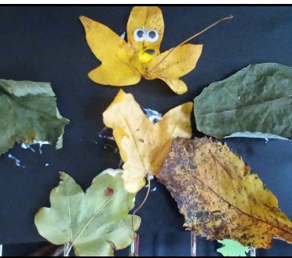

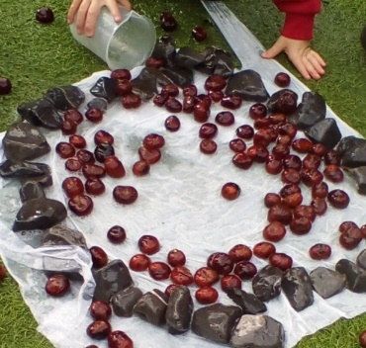

Progression of knowledge document
National Curriculum links: Art and Design Music

Creating with Materials
 | Nursery | End of year Goals (School Readiness) | Reception | End of term checkpoints
Autumn 1 | Formal elements  What is colour?  Explore colour and where we see it. How can we use colour. |  | Formal elements  What are primary colours?  Paint using primary colours.  Choose a primary colour for the right purpose. | - Can they name the primary colours?  - Can they hold a paintbrush and begin to wash their brush before changing colour?  - Can they select appropriate primary colours for their paintings?
Autumn 2 | Formal elements  What is a line?  Where can we see different lines.  Drawing Unit  How do we hold a pencil to mark make?  Understand how to hold a pencil/crayon, felt tip etc. and make marks. |  | Formal elements  What can we use to create lines?  Use line templates to create lines using different mediums.  Drawing unit  How can I represent my ideas more accurately?  Understand how what we want to draw can be made up of more than what we can imagine. | - Can they confidently use stencils to create lines?  - Can the children look closely at an object and begin to draw what they can see?
Spring 1 | Formal elements  What are the 2D shapes?  Explore 2D shapes in the environment.  Fashion Design  What do I wear?  Explore different clothes and how we dress. |  | Formal elements  Can we find shapes in the world around us?  Identify 2D shapes in the environment.  Fashion Design  What do I wear to celebrative occasions?  Explore how different people and cultures dress for special occasions such as birthdays and Christmas etc. | - Can they find 2D shapes in learning environments?  - Can they name some 2D shapes?  - Can they begin to recognise that people dress for special occasions and there are similarities and differences?
Spring 2 | Formal elements  What can we feel?  Feel different textures around the environment and name the texture.  Sugar Art  How does icing sugar feel to touch?  Explore using icing sugar in tough trays to mark make. |  | Formal elements  Does everything feel the same?  Compare different textures in the environment.  Sugar Art  When do we see sugar art?  Explore when we will see different types of sugar art focussing on celebrative occasions. | - Can they begin to sort materials into groups depending on how they feel?  - Can the children describe how they feel?  - Can the children create mood boards by cutting out different cakes that show different sugar art  - Can the children make icing with support and decorate their biscuit?
Summer 1 | Formal elements  What structures can we create in our environment?  Use the environment to choose materials to create a structure play.  Paper crafts  What is paper?  Explore how different papers feel. |  | Formal elements  What structures can we create in our environment?  Use the environment to choose materials to create a structure play.  Paper crafts  Where does paper come from?  Understand how paper is made. | - Can they use a wide range of building materials to create?  - Can they talk about how paper is made?
Summer 2 | Formal elements  What structures can we create in our environment?  Use the environment to choose materials to create a structure play.  Inspirations Artists  What is an artist?  Understand that an artist is someone who creates art. |  | Formal elements  What structures can we create in our environment?  Use the environment to choose materials to create a structure play.  Inspirations Artists  What is a contemporary artist?  Understand that a contemporary artists is someone who creates art in a contemporary style.  What medium has been used to create this piece?  Understand that different pieces of art can be created using different forms and elements such as: drawing, and painting.  Can we say if we like or dislike an art piece?  Understand whether they like an art piece or not. | Early Learning Goals:  ELG : Creating with Materials  -Safely use and explore a variety of materials, tools and techniques, experimenting with colour, design, texture, form and function;  - Share their creations, explaining the process they have used;  -Make use of props and materials when role playing characters in narratives and stories.  ELG: Being Imaginative and Expressive  - Invent, adapt and recount narratives and stories with peers and their teacher;  - Sing a range of well-known nursery rhymes and songs  - Perform songs, rhymes and poems with others, and – when appropriate try and move in time with music.

Being Imaginative and Expressive
Children in EYFS will develop their musical understanding through exploring a wide range of musical instruments from different cultures. We will learn songs and poems from memory and explore the pitch and tempo of songs. We will find the pulse/beat in songs and clap a rhythm over a steady beat/pulse. Our environments across EYFS support and develop children’s imagination through our rich selection of open-ended resources.

