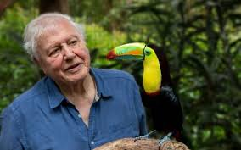
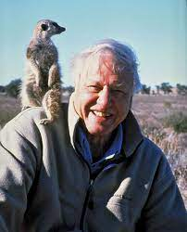
Explores and Adventurers
David Attenborough
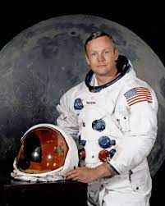
Moana
Dora the Explorer
Neil Armstrong

Key Vocabulary
Explorer | An explorer is someone who goes on an exploration.
Exploration | A journey where explorers travel to unfamiliar places.
Polar | Used when talking about anything to do with the North Pole or the South Pole.
Recent | In the past but not long time ago.
Significant | Important and worth knowing about.
Voyage | A long journey, especially by ship. The word voyage can also be used to describe journeys in space.
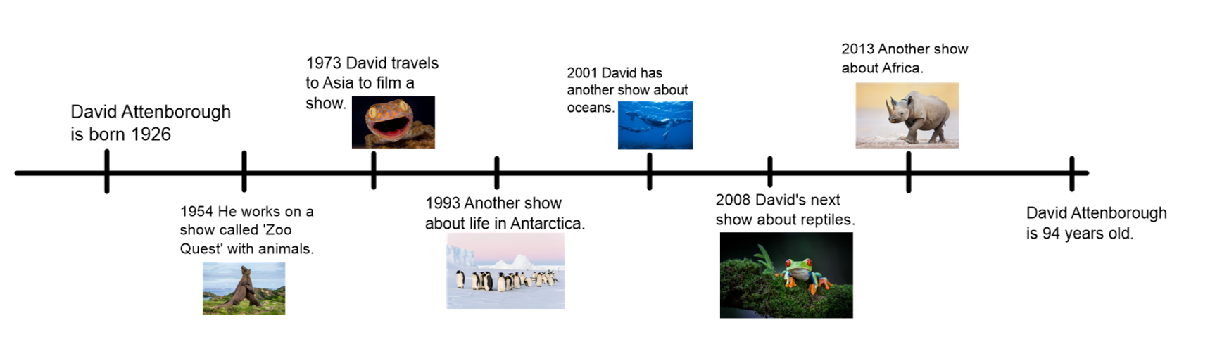
Timeline of David Attenborough’s life.
Challenge:
Can you design a habitat for an animal that David Attenborough has visited?

