Working Together To Protect Our Children
November 2018
Dear Parent/Carer
Further to our letter sent out recently regarding our online course for internet safety, I have arranged to present this course in person to any parent/carer that is unable to access the internet or would prefer to learn in a face to face/ group environment.
The presentation will be held on Thursday 6th December 2018 at 3.10pm. Children are welcome to attend with their parent/carer also.
If you would like advice regarding parental controls please feel free to bring your tablets/devices along and I will support as best I can.
All participants will receive a certificate after the course stating their completion along with being entered into our prize draw in February with all parents who have accessed the course independently.
Just a reminder that 3 lucky winners will be pulled out at random and win one of the following prizes which have been donated by Nationwide School Uniforms:
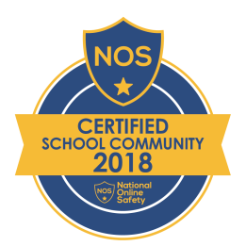

Winners will announced In March 2019
If you would like to attend please contact the school office to put your name down
We look forward to seeing you soon!!!!
Kind regards
Mr Clay
Headteacher

