Year 2 Holiday Homework

After the half term, we will be exploring Traditional Tales. This will lead up to our Christmas pantomime of Cinderella.

We are inviting you to design or even make, a castle from a Traditional Tale.
You can be as creative as you like.
Below are some ideas:

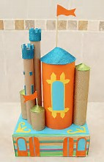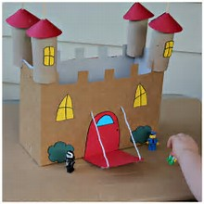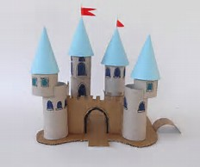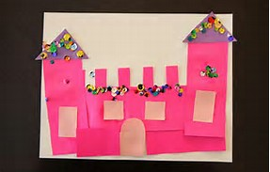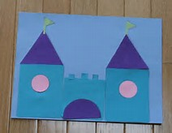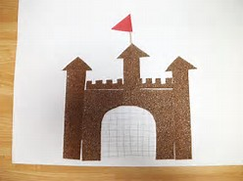 Enjoy!

